CAPSTONE PROJECT REPORT
(Project Term January-May 2026)

Adaptive Currency Recognition for the Blind

Submitted by

Akanksh Vuggi Registration Number : 12210806
K Jaya Sravani Registration Number : 12212274

Project Group Number : G1 Course Code : CSE-461

Under the Guidance of

Karan Kumar Das Delivery and Student Success

School of Computer Science and Engineering



DECLARATION STATEMENT

I hereby declare that the research work reported in the dissertation/dissertation proposal entitled "Adaptive Currency Recognition for the Blind” in partial fulfilment of the requirement for the award of Degree for Bachelor of Technology in Computer Science and Engineering at Lovely Professional University, Phagwara, Punjab is an authentic work carried out under supervision of my research supervisor Karan Kumar Das. I have not submitted this work elsewhere for any degree or diploma.

I understand that the work presented herewith is in direct compliance with Lovely Professional University’s Policy on plagiarism, intellectual property rights, and highest standards of moral and ethical conduct. Therefore, to the best of my knowledge, the content of this dissertation represents authentic and honest research effort conducted, in its entirety, by me. I am fully responsible for the contents of my dissertation work.

Akanksh Vuggi 12210806

K Jaya Sravani
12212274

(Signature of Student 1) Date:

(Signature of Student 2) Date:

CERTIFICATE
This is to certify that the declaration statement made by this group of students is correct to the best of my knowledge and belief. They have completed this Capstone Project under my guidance and supervision. The present work is the result of their original investigation, effort and study. No part of the work has ever been submitted for any other degree at any University. The Capstone Project is fit for the submission and partial fulfillment of the conditions for the award of B.Tech degree in School of Computer Science and Engineering from Lovely Professional University, Phagwara.

Signature
Karan Kumar Das
School of Computer Science and Engineering,
Lovely Professional University, Phagwara, Punjab.

Date :

ACKNOWLEDGEMENT

We would like to express our deepest gratitude to all those who have contributed to the successful completion of our project titled “Adaptive Currency Recognition for the Blind”. This project would not have been possible without the guidance, support, and encouragement of numerous individuals and organizations.

First and foremost, we extend our heartfelt thanks to our project guide, Kaushal Pathak, Delivery and Student Success, UpGrad Campus, for their invaluable guidance, constant encouragement, and insightful feedback throughout the project. Their expertise and patience have been instrumental in shaping this work and helping us overcome challenges at every stage.

We are also grateful to the faculty members of the School of Computer Science and Engineering at Lovely Professional University for their unwavering support and for providing us with the necessary resources and infrastructure to carry out this project.

TABLE OF CONTENTS

Inner first page (i)
PAC form (ii)
Declaration (iii)
Certificate (iv)
Acknowledgement (v)
Table of Contents (vi)

TABLE OF CONTENTS

CHAPTER 1. | INTRODUCTION | 1
CHAPTER 2. | PROBLEM STATEMENT | 3
2.1. | PROFILE OF THE PROBLEM | 3
2.2. | RATIONALE / SCOPE OF THE STUDY | 3
CHAPTER 3. | LITERATURE REVIEW | 5
3.1. | INTRODUCTION | 5
3.2. | EXISTING SOFTWARE | 5
 | 3.2.1 ML AND DL FOR PNEUMONIA DETECTION | 5
 | 3.2.2 CNNs IN MEDICAL IMAGING | 6
 | 3.2.3 GAPS AND CHALLENGES OF CURRENT WORK | 6
3.3. | DFD FOR PRESENT SYSTEM | 6
3.4. | WHAT’S NEW IN THE SYSTEM TO BE DEVELOPED | 9
CHAPTER 4. | PROBLEM ANALYSIS (RESEARCH METHODOLOGY) | 10
4.1. | PRODUCT DEFINITION | 10
4.2. | FEASIBILITY ANALYSIS | 10
4.3. | PROJECT PLAN | 11
CHAPTER 5. | SOFTWARE REQUIREMENT ANALYSIS | 12
5.1. | INTRODUCTION | 12
5.2. | GENERAL DESCRIPTION | 12
5.3. | SPECIFIC REQUIREMENTS | 12
 | 5.3.1 FUNCTONAL REQUIREMENTS | 13
 | 5.3.2 NON-FUNCTIONAL REQUIREMENTS | 13
CHAPTER 6. | DESIGN | 15
6.1. | SYSTEM DESIGN | 15
6.2. | DESIGN NOTATIONS | 17
6.3. | DETAILED DESIGN | 21
6.4. | FLOWCHARTS | 21

    - DATA LOADING AND PREPROCESSING 27
6.5. | PSEUDO CODE | 27

    - CNN MODEL 30
    - TRANSFER LEARNING WITH PRETRAINED MODEL 33
    - MODEL TRAINING 35
    - MEDICAL IMAGE PROCESSING AND DIAGNOSIS 38
    - PERSONALIZED HEALTH ADVICE GENERATION 39
    - USER AUTHENTICATION AND ROLE MANAGEMENT 41
    - AUTOMATED HEALTH MONITORING AND ALERTS 43
    - ADMINISTRATIVE CONTROLS AND
DATA MANAGEMENT 44

CHAPTER 7. | TESTING | 46
7.1. | FUNCTIONAL TESTING | 46
7.2. | STRUCTURAL TESTING | 48
7.3. | LEVELS OF TESTING | 49
7.4. | TESTING THE PROJECT | 51
CHAPTER 8. | IMPLEMENTATION | 52
8.1. | IMPLEMENTATION OF THE PROJECT | 52
8.2. | CONVERSION PLAN | 53
8.3. | POST-IMPLEMENTATION AND SOFTWARE MAINTENANCE | 54
CHAPTER 9. | PROJECT LEGACY | 57
9.1. | CURRENT STATUS OF THE PROJECT | 57
9.2. | REMAINING AREAS OF CONCERN | 58
9.3. | TECHNICAL AND MANAGERIAL LESSONS LEARNT | 61

CHAPTER 10. USER MANUAL 63
  - INTRODUCTION 63
  - PURPOSE OF THE SYSTEM 63

  - SYSTEM OVERVIEW 63
  - SYSTEM REQUIREMENTS 64
  - RUNNING THE APPLICATION 65
  - USING THE APPLICATION 65
  - MEDICAL HIATORY AND RECORD TRACKING 68
  - FEATURES AND CAPABILITIES 68
  - TROUBLESHOOTING AND SUPPORT 69
  - LIMITATIONS OF THE SYSTEM 69
  - CLOSING THE APPLICATION 70
  - FUTURE ENHANCEMENTS 70
  - CONCLUSION 70
- SOURCE CODE 71
- REFERENCE 82

LIST OF FIGURES

Fig 1. Level 0 Data Flow Diagram 7
Fig 2. Level 1 Data Flow Diagram 7
Fig 3. Level 2 Data Flow Diagram 8
Fig 4. Level 3 Data Flow Diagram 8
Fig 5. Entity Relationship Diagram of the system 17
Fig 6. Sequence Diagram of the system 17
Fig 7. Class Diagram of the system 18
Fig 8. Flowchart of the system 25
Fig 9. Architecture of the UI 26
Fig 10. Train and test dataset information 71
Fig 11. Custom CNN used in training the images 71
Fig 12. Custom CNN and binary cross entropy 72
Fig 13. Transfer learning using pretrained model 72
Fig 14. Transfer learning using pretrained model and its layers 73
Fig 15. Fine tuning on image dataset 73
Fig 16. Fine tuning on image dataset and its unfreeze layers 74
Fig 17. Saving model for deployment 74
Fig 18. Code for deploying the saved model using Fast API 75
Fig 19. Fast API UI where user can input X-ray image 76
Fig 20. Detection of lungs suffering from pneumonia 76
Fig 21. Detection of normal healthy lungs 77
Fig 22. LLM model-Ollama3 77
Fig 23. Notification and remainder code 78
Fig 24. Unit testing code for each profile 78
Fig 25. Log-in and Sign-up page in Stream UI 79
Fig 26. Logged in as Admin and user respectively 79
Fig 27. Profile to get treatment guidance 80
Fig 28. UI to update the symptoms or addition/ reduction of disease 80
Fig 29. UI to create new profile 80
Fig 30. UI to delete profile 81

INTRODUCTION
Vision plays a vital role in enabling individuals to interact with their surroundings and perform daily activities efficiently. For visually impaired individuals, the inability to perceive visual information creates significant barriers in performing routine tasks that sighted individuals often take for granted. One such critical activity is the identification and handling of physical currency during financial transactions. Despite technological progress in digital payments, cash remains a dominant medium of exchange in many regions, particularly in developing economies and rural areas. Consequently, the challenge of identifying currency denominations continues to impact the independence and confidence of visually impaired individuals on a daily basis.
Currency notes are primarily designed for visual recognition, relying heavily on colors, numerical values, symbols, and images to differentiate denominations. Although some countries incorporate tactile features such as raised markings or size variations, these features are often inadequate due to deterioration of notes, inconsistent tactile standards, or limited user familiarity. Moreover, visually impaired individuals may encounter difficulties in low-light environments, crowded public spaces, or situations that require quick monetary decisions, further intensifying the need for an automated and reliable currency identification system.
Assistive technologies have emerged as a powerful means of reducing these accessibility barriers. Advances in computer vision, machine learning, and artificial intelligence have enabled systems to interpret visual data with high accuracy, mimicking certain aspects of human perception. Image classification and object recognition techniques allow machines to learn discriminative features from large datasets, making them suitable for real-world recognition tasks. When applied to currency recognition, these techniques can analyze unique visual characteristics such as color distributions, texture patterns, embedded symbols, serial number regions, and denomination-specific layouts.

The Adaptive Currency Recognition for the Blind project is conceived as an intelligent assistive solution that harnesses these technological advancements to address a real-world social problem. The system is designed to capture images of currency notes using a camera-based interface and process them through a sequence of image preprocessing, feature extraction, and classification stages. Unlike conventional systems that assume ideal conditions, the proposed approach emphasizes adaptability, enabling the system to perform reliably under varying illumination levels, different note orientations, partial occlusions, and background clutter. This adaptability is crucial for practical deployment, as visually impaired users cannot be expected to position currency notes in a fixed or controlled manner.
An essential component of the system is its audio feedback mechanism, which communicates the recognized denomination through synthesized voice output. This ensures complete hands-free and vision-independent interaction, making the system intuitive and accessible. By transforming visual recognition results into auditory cues, the system bridges the gap between complex machine learning processes and real-world usability for visually impaired individuals.
From a broader perspective, this project aligns with the principles of inclusive and human-centered design, where technology is developed not merely for innovation but for meaningful social impact. By promoting independence in financial transactions, the system helps restore a sense of privacy, dignity, and self-reliance among visually impaired users. Furthermore, the solution is designed to be cost-effective and scalable, allowing potential deployment on widely available platforms such as smartphones or low-cost embedded devices.
The primary aim of this project is to develop a robust, accurate, and user-friendly currency recognition system that enhances accessibility and inclusivity. Through the integration of machine learning algorithms, image processing techniques, and assistive audio interfaces, the project demonstrates how emerging technologies can be effectively leveraged to solve real-life problems. Ultimately, Adaptive Currency Recognition represents a step toward a more equitable digital society, where technological advancements are accessible to all, regardless of physical limitations.

PROBLEM STATEMENT
Visually impaired individuals face significant challenges in performing everyday activities that require visual perception. Among these challenges, identifying physical currency during financial transactions remains a critical and unresolved problem. Despite the availability of digital payment systems, cash transactions continue to be widely used in daily life, including in public transport, retail markets, educational institutions, and emergency situations. The inability to independently recognize currency denominations limits financial autonomy and increases dependence on others, thereby affecting personal confidence, privacy, and security.
Currency notes are primarily designed for visual identification through printed numbers, colors, images, and patterns. For visually impaired users, these visual cues are inaccessible, making it difficult to differentiate between denominations. Although some tactile features exist, they are often unreliable due to note wear, inconsistent embossing, or lack of standardization across different denominations and currency series. As a result, visually impaired individuals frequently rely on external assistance or memory-based assumptions, which can lead to incorrect transactions and financial loss.
Existing assistive solutions for currency recognition suffer from several limitations. Manual methods, such as tactile identification or assistance from others, are error-prone and compromise independence. Some electronic devices designed for currency detection are expensive, bulky, and limited to specific currencies or controlled environments. Mobile-based solutions may struggle with poor lighting conditions, background noise, camera misalignment, or partially visible notes. These constraints highlight the need for a more adaptive, reliable, and user-centric currency recognition system that can operate effectively in real-world conditions.
The core problem addressed in this project is the lack of an accessible and accurate system that enables visually impaired individuals to independently identify currency denominations in real time. The system must be capable of handling variations in lighting, orientation, scale, and physical condition of currency notes while providing instant and clear feedback to the user. Without such a solution, visually impaired individuals remain dependent on others for basic financial interactions, limiting their independence and social participation.

PROFILE OF THE PROBLEM
Handling paper currency is an everyday requirement, but for individuals with visual impairments, identifying currency denominations accurately is a persistent difficulty. In the absence of visual cues, visually impaired users often depend on external help to recognize currency notes, which can lead to inconvenience, loss of privacy, and reduced independence during financial transactions.
Although several assistive tools and mobile applications have been developed to address this issue, many of them suffer from practical limitations. Some require manual image capture or physical interaction, while others depend on internet connectivity or specialized devices. These constraints reduce their effectiveness in real-world environments such as shops, streets, or public transport systems where quick and reliable identification is essential.
Indian currency notes present additional challenges due to their visual similarity, complex designs, and frequent exposure to varied conditions. Notes may appear folded, partially occluded, worn out, or viewed under uneven lighting and cluttered backgrounds. Such variations make it difficult for traditional image processing techniques to perform consistent and accurate recognition.
The key problem addressed in this project is the lack of a real-time, offline, and hands-free currency recognition system that can operate reliably using commonly available hardware. An effective solution must be capable of continuously analyzing live visual input, accurately distinguishing between different denominations, and conveying the result through an audio response without requiring visual interaction from the user.

Advances in deep learning, particularly convolutional neural networks, provide the capability to automatically learn meaningful visual patterns from images and perform robust classification tasks. However, applying these techniques in a live, user-friendly assistive system requires careful integration of image acquisition, preprocessing, model inference, and audio output in a seamless and efficient manner.
This project focuses on addressing these challenges by developing an adaptive currency recognition system that uses live webcam input to identify Indian currency denominations and immediately communicate the result through speech. The objective is to provide a practical, accessible, and dependable solution that enhances the independence and confidence of visually impaired users during everyday financial interactions.

RATIONALE / SCOPE OF THE STUDY
The primary motivation for undertaking this study is to address the real-world difficulties faced by visually impaired individuals in identifying currency denominations independently. Financial transactions are an essential part of daily life, and the inability to recognize currency accurately can result in dependency, vulnerability to errors, and reduced confidence. Developing a technological solution that minimizes these challenges is therefore both socially relevant and practically important.
With the rapid advancement of artificial intelligence, particularly deep learning, image classification tasks that were previously difficult to automate can now be performed with high accuracy. Convolutional Neural Networks have demonstrated strong performance in recognizing complex visual patterns under varied conditions. This study leverages these advancements to design a system capable of recognizing Indian currency notes reliably in real time.
Another key rationale behind this work is the need for an offline and accessible solution. Many existing assistive applications rely on internet connectivity or cloud-based services, which may not be available or reliable in all environments. By implementing an offline model and local text-to-speech mechanism, the proposed system ensures uninterrupted usage regardless of network availability.
Additionally, this project emphasizes ease of use by eliminating the need for manual input or visual interaction. The hands-free, browser-based design allows users to simply present a currency note in front of a camera and receive immediate audio feedback, making the system practical for everyday use.
Scope of the Study
The scope of this study is limited to the recognition of Indian paper currency denominations, specifically ₹10, ₹20, ₹50, ₹100, ₹200, ₹500, and ₹2000. The system focuses on identifying the denomination of a single currency note presented in front of a webcam in real-time conditions.
The study covers the design and training of a convolutional neural network for currency classification, image preprocessing techniques to handle variations in lighting and orientation, and the integration of the trained model into a web-based application. The system includes an audio feedback mechanism to communicate the recognized denomination to the user.
The implementation is intended to run on standard consumer hardware using a web browser and does not require specialized sensors or external devices. The scope does not extend to recognizing counterfeit notes, detecting damaged currency beyond classification, or supporting foreign currencies.
Future enhancements such as mobile deployment, multi-currency support, counterfeit detection, and improved robustness under extreme environmental conditions are acknowledged but remain outside the current scope of this study.

LITERATURE REVIEW

INTRODUCTION

The literature review provides an overview of previous research and technological developments related to currency recognition and image-based classification systems. It aims to analyze existing methods, tools, and models that have been proposed to address similar problems, particularly in the areas of assistive technology, computer vision, and machine learning. By examining earlier work, this section helps identify established approaches as well as their limitations.
Over the years, researchers have explored various techniques for recognizing currency notes using digital images. Early systems primarily relied on traditional image processing methods such as edge detection, color analysis, texture extraction, and handcrafted feature descriptors. While these methods showed some success under controlled conditions, their performance often degraded when exposed to real-world variations such as changes in lighting, orientation, background clutter, and physical wear of currency notes.
With the advancement of machine learning, classification algorithms such as k-nearest neighbors, support vector machines, and decision trees were introduced to improve recognition accuracy. These approaches required manually designed features and extensive preprocessing, making them sensitive to noise and less adaptable to diverse environments. As a result, their practical applicability in real-time assistive systems remained limited.
Recent developments in deep learning, especially convolutional neural networks, have significantly improved the capability of automated image recognition systems. CNNs are able to learn hierarchical visual features directly from raw images, reducing the need for manual feature engineering. This has led to improved robustness and accuracy in various image classification tasks, including object recognition, medical imaging, and currency identification.
The reviewed literature highlights a growing interest in applying deep learning techniques to assistive applications. However, many existing solutions focus primarily on classification accuracy while overlooking practical aspects such as real-time performance, offline operation, and user accessibility. These gaps provide the foundation for the proposed system, which aims to combine deep learning-based currency recognition with a real-time, audio-driven interface designed specifically for visually impaired users.

EXISTING SOFTWARE AND RESEARCH CONTRIBUTIONS
Several software systems and research efforts have been proposed to assist visually impaired individuals in identifying currency denominations using digital images. These systems vary in terms of technology used, level of automation, and practical usability. Most existing solutions can be broadly categorized into traditional image processing–based systems, machine learning–based applications, and deep learning–based recognition models.
Early software solutions for currency recognition relied heavily on classical image processing techniques. These systems extracted handcrafted features such as color histograms, edge patterns, texture descriptors, and geometric properties of currency notes. Rule-based algorithms were then applied to classify denominations based on these extracted features. While such approaches performed reasonably well under controlled lighting and background conditions, their accuracy dropped significantly when faced with real-world variations such as folds, shadows, occlusions, and worn-out notes. Additionally, these systems often required manual image capture and preprocessing, limiting their suitability for real-time use.
With the introduction of machine learning, researchers began integrating classifiers such as k-nearest neighbors, support vector machines, and decision trees into currency recognition systems. These models improved classification performance compared to purely rule-based methods. However, they still depended on manually engineered features, making the systems sensitive to noise and dataset-specific variations. Moreover, most implementations focused on static image input rather than continuous live video streams.
Recent research contributions have increasingly adopted deep learning techniques, particularly convolutional neural networks, to address the limitations of earlier approaches. CNN-based systems automatically learn discriminative visual features from raw images, enabling better generalization across different lighting conditions, orientations, and backgrounds. Several studies have reported high classification accuracy for currency recognition tasks using CNN architectures trained on labeled image datasets.
Despite these advancements, many existing software solutions remain limited in terms of real-world usability. A significant number of systems rely on cloud-based inference or require constant internet connectivity, which may not be feasible in all environments. Some applications require explicit user interaction, such as pressing buttons or capturing images manually, which can be challenging for visually impaired users. In addition, few systems provide immediate and continuous audio feedback suitable for real-time assistance.
The analysis of existing software and research contributions indicates a clear need for a system that combines high recognition accuracy with practical accessibility features. An effective solution should operate offline, support real-time video input, minimize user interaction, and provide reliable audio output. These observations form the basis for the proposed system, which aims to address the identified limitations by integrating a deep learning–based recognition model with a browser-based, hands-free interface designed specifically for visually impaired users.
3.2.1 Machine Learning and Deep Learning for Currency Recognition
Machine learning techniques have been used in currency recognition systems to automate the classification of currency denominations from images. Early approaches relied on manually extracted features such as color patterns, edges, textures, and shapes, which were then classified using algorithms like k-nearest neighbors or support vector machines. Although these methods improved recognition compared to rule-based techniques, their performance was highly dependent on feature design and controlled imaging conditions.
Deep learning approaches, particularly convolutional neural networks, introduced a major improvement by learning relevant features directly from raw images. CNN-based models demonstrated higher accuracy and better robustness to variations in lighting, orientation, and background. By using large datasets and data augmentation techniques, deep learning systems were able to generalize more effectively to real-world conditions. As a result, deep learning has become the preferred approach for modern currency recognition systems.
3.2.2 Convolutional Neural Networks in Image Classification
Convolutional Neural Networks are widely used for image classification tasks due to their ability to automatically learn hierarchical visual features. CNNs use convolutional layers to extract low-level features such as edges and textures, and deeper layers to capture complex patterns and structural information. Pooling layers reduce spatial dimensions, while fully connected layers perform final classification.
In image recognition applications, CNNs have achieved strong performance across diverse domains, including object detection, face recognition, and document analysis. Their ability to handle spatial variations makes them well-suited for recognizing currency notes that may appear under different orientations, scales, and lighting conditions. This makes CNNs an effective choice for real-time currency denomination recognition systems.
3.2.3 Gaps and Challenges of Current Work
Despite significant progress, existing currency recognition systems face several limitations. Many solutions rely on static image capture or require manual user interaction, which is inconvenient for visually impaired users. Some systems depend on internet connectivity or cloud-based processing, reducing reliability in offline environments.
Additionally, high computational requirements of deep learning models can limit real-time performance on standard hardware. Variations such as blurred images, partially visible notes, and worn currency continue to pose challenges. These gaps highlight the need for an offline, real-time, and hands-free system that combines high accuracy with accessibility, which forms the motivation for the proposed work.

DATA FLOW DIAGRAM (DFD) OF THE SYSTEM
Fig 1. Level 0 Data Flow Diagram 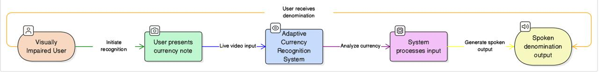

Description
The Level 0 DFD represents the system as a single process and shows its interaction with the external user.
External Entity
- Visually Impaired User
Process
- Adaptive Currency Recognition System
Data Flow
    - User presents currency note → Live video input
    - System processes input → Spoken denomination output

WHATS NEW IN THE PROPOSED SYSTEM?

The proposed Adaptive Currency Recognition System addresses all five of the identified gaps. It is trained on a self-collected, diverse dataset of all seven Indian Rupee denominations captured under varied real-world conditions. It is implemented as a complete, deployable web application with live webcam input and immediate speech output. It operates entirely offline without internet dependency, using on-device inference and local TTS. And it is designed specifically for Indian Rupee notes, incorporating the post-2016 note designs.

The system advances the state of the art in the Indian context by combining all necessary components — data collection, model training, web application development, and TTS integration — into a single, cohesive, deployable pipeline. Table 3.1 summarizes the comparison between the proposed system and existing approaches.

Table 31: Comparison of Proposed System with Existing Approaches
Feature | Traditional Methods | Classical ML | Existing CNN Systems | Proposed System
Real-time Webcam Input | No | No | Partial | Yes
Indian Rupee Support | Partial | Partial | Partial | Full (All 7 denominations)
Real-world Dataset | No | No | Limited | Yes (self-collected, diverse)
Audio Output (TTS) | No | No | Rare | Yes (pyttsx3, offline)
Offline Operation | Yes | Yes | No (cloud-based) | Yes
Web Application | No | No | No | Yes (Django)
Accuracy under varied conditions | Low | Moderate | High (controlled) | High (real-world)

PROBLEM ANALYSIS

Problem analysis involves a detailed examination of the existing scenario to identify current challenges, limitations, and gaps that need to be addressed. Many present-day systems are either partially automated or rely heavily on manual processes, which leads to inefficiency, increased error rates, and delayed outcomes. These systems often lack adaptability, scalability, and intelligent decision-making capabilities.
In addition, users frequently face difficulties due to complex interfaces, lack of real-time responses, and limited system feedback. Data handling issues such as inconsistency, redundancy, and inadequate security further reduce system reliability. As the volume of data and number of users grow, traditional systems struggle to maintain performance and accuracy.
The absence of an integrated, intelligent, and user-friendly solution creates a need for a new system that can overcome these limitations. Therefore, analyzing these problems helps in defining clear objectives and functional requirements for the proposed system.

PRODUCT DEFINITION

The proposed product is an intelligent, automated software system designed to efficiently perform core operations while minimizing manual intervention. It aims to simplify complex processes by providing accurate, real-time results through an intuitive and easy-to-use interface.
The product accepts user inputs, processes them using well-defined logic and intelligent mechanisms, and generates meaningful outputs in a timely manner. It is designed with a modular structure, allowing future enhancements and easy maintenance. The system ensures reliable data handling, improved performance, and secure storage of information.
By combining automation, intelligence, and usability, the product serves as a comprehensive solution to the identified problems. It is suitable for real-world deployment where accuracy, efficiency, scalability, and user satisfaction are essential.

FEASIBILITY ANALYSIS
Feasibility analysis evaluates whether the proposed system can be developed and implemented effectively within given constraints. It examines the practicality of the system from technical, economic, and operational perspectives to ensure successful execution.
4.2.1 Technical Feasibility
The proposed system is technically feasible as it is built using widely available and proven technologies. The required hardware components such as a standard computer or mobile device and basic peripherals are easily accessible. Software tools and frameworks used for development support machine learning, image processing, and user interface design, making implementation achievable without the need for specialized or proprietary infrastructure.
4.2.2 Economic Feasibility
The system is economically viable since it utilizes open-source libraries and free development environments, significantly reducing development and deployment costs. No expensive hardware or licensed software is required. Maintenance costs are minimal, making the solution affordable and sustainable for long-term use.
4.2.3 Operational Feasibility
The system is designed to be user-friendly and accessible, ensuring smooth adoption by end users. Minimal training is required due to its intuitive interface and automated functionality. The system integrates well into real-world environments and can be operated efficiently with basic user interaction.
Overall, the feasibility analysis confirms that the proposed system can be developed and deployed successfully within the available resources, time, and budget constraints.

PROJECT PLAN
The project plan outlines the systematic approach followed to design, develop, and implement the proposed system. The project is divided into multiple phases to ensure smooth execution, proper monitoring, and timely completion.
Phase 1: Requirement Analysis
This phase focuses on understanding the problem domain, identifying user needs, and defining system requirements. Functional and non-functional requirements are gathered through analysis of existing systems and project objectives.
Phase 2: Literature Review and Research
Relevant research papers, existing software solutions, and technical resources are studied to understand current approaches and identify gaps. This phase helps in selecting appropriate algorithms, tools, and technologies.
Phase 3: System Design
The overall architecture, data flow, and system modules are designed in this phase. Design decisions are made to ensure scalability, efficiency, and ease of use. Data Flow Diagrams and workflow models are prepared.
Phase 4: Implementation
The system is developed according to the defined design using suitable programming languages and frameworks. Individual modules are coded, integrated, and optimized to ensure correct functionality.
Phase 5: Testing and Validation
Comprehensive testing is conducted to verify system performance, accuracy, and reliability. Errors and inconsistencies are identified and corrected to ensure the system meets expected requirements.

Phase 6: Deployment and Documentation
The final system is deployed in the intended environment. User documentation and technical reports are prepared to support future usage, maintenance, and enhancements.
This structured project plan ensures effective resource utilization, risk reduction, and successful completion of the project within the stipulated timeframe.

SOFTWARE REQUIREMENT ANALYSIS

INTRODUCTION
Software Requirement Analysis is a critical phase in the system development lifecycle that focuses on identifying and documenting the exact needs of the proposed system. This stage ensures a clear understanding of system objectives, user expectations, and operational constraints before moving into design and implementation.
For the Adaptive Currency Recognition for the Blind project, this phase defines the technical and functional requirements necessary to build an accessible and reliable solution. The system must accurately recognize currency denominations from real-time visual input and deliver results in an audio format suitable for visually impaired users. Proper requirement analysis helps in minimizing development errors, improving system usability, and ensuring that the final application meets both performance and accessibility goals.
This chapter outlines the overall system expectations, constraints, and capabilities, serving as a blueprint for subsequent development phases.

GENERAL DESCRIPTION

The Adaptive Currency Recognition for the Blind system is a web-based assistive application designed to identify Indian currency denominations in real time and convey the result through voice output. The system operates by capturing live visual input from a webcam, processing the image using a trained deep learning model, and announcing the detected denomination without requiring any manual interaction from the user.
The application follows a client–server architecture. The frontend, accessed through a standard web browser, is responsible for activating the webcam and transmitting captured frames to the backend. The backend, developed using the Django framework, handles image decoding, preprocessing, model inference, and text-to-speech generation. The system is optimized to function entirely offline after initial setup, ensuring usability in environments with limited or no internet access.
The target users of the system are visually impaired individuals who require a fast, accurate, and dependable method to identify currency during everyday transactions. The system is designed to be simple, responsive, and robust, supporting all commonly used Indian Rupee denominations while maintaining high accuracy under varying lighting and background conditions.

SPECIFIC REQUIREMENTS

The functional requirements describe the specific operations and behaviors the Adaptive Currency Recognition for the Blind system must perform to achieve its intended purpose.
- Webcam Access
The system shall access the user’s webcam through a web browser to capture live video input.
- Real-Time Image Capture
The system shall continuously capture image frames at regular intervals without requiring user interaction.
- Image Preprocessing
The system shall preprocess captured frames by resizing, normalizing, and formatting them to match the input specifications of the trained deep learning model.
- Currency Detection and Classification
The system shall analyze the processed image using a trained convolutional neural network to identify the Indian currency denomination.
- Confidence-Based Validation
The system shall evaluate prediction confidence and proceed only when the confidence level exceeds a predefined threshold to avoid incorrect announcements.
- Audio Output Generation
The system shall convert the detected denomination into spoken audio using an offline text-to-speech engine.
- Result Display
The system shall display the detected denomination and confidence score on the browser interface for monitoring purposes.
- Error Handling
The system shall handle invalid inputs or unclear images by refraining from producing misleading audio output.
- System Initialization
The system shall load the trained model and required resources automatically during server startup.

5.4 Functional Requirements

5.4.1 Image Capture
- The system shall capture live video from the user's webcam at a minimum frame rate of 10 frames per second.
- The system shall display the live webcam feed to the user in the browser interface.
- The system shall allow the user to initiate currency detection by a single click (or equivalently, operate in continuous detection mode without user interaction).
- The system shall handle webcam access failures gracefully, displaying an informative error message if the webcam is unavailable.
5.4.2 Image Preprocessing
- The system shall preprocess captured frames by resizing them to 224×224 pixels prior to model inference.
- The system shall normalize pixel values to the range [0, 1] by dividing by 255.
- The system shall apply noise reduction using Gaussian blurring with a 3×3 kernel to reduce the impact of camera noise on classification accuracy.
- The system shall convert images from BGR (OpenCV default) to RGB colour space for compatibility with the trained model.
5.4.3 Currency Classification
- The system shall classify preprocessed images into one of seven denomination classes: ₹10, ₹20, ₹50, ₹100, ₹200, ₹500, and ₹2000.
- The system shall load the trained CNN model from a .h5 file at application startup and reuse the loaded model for all subsequent inference requests without reloading.
- The system shall return the predicted denomination label and the associated confidence score for each classification.
- The system shall only trigger audio output when the prediction confidence exceeds a configurable threshold (default: 0.85) to avoid erroneous announcements for ambiguous inputs.
5.4.4 Audio Output
- The system shall synthesize speech output for the recognized denomination using the pyttsx3 text-to-speech library.
- The system shall speak the denomination in a clear, complete sentence, e.g., 'Detected: One Hundred Rupees'.
- The system shall operate the TTS engine offline, without requiring internet connectivity.
- The system shall avoid repeated announcements of the same denomination within a configurable debounce interval (default: 2 seconds) to prevent excessive audio output during continuous detection.
5.4.5 Web Application
- The system shall be served by a Django development server accessible via a standard web browser on the localhost.
- The system shall provide a simple, minimal browser interface displaying the live webcam feed and the most recently detected denomination.
- The system shall handle concurrent frame submissions from the browser without blocking or crashing.
- The system shall serve the inference endpoint as a Django view accepting HTTP POST requests with image data.
5.4 Non-Functional Requirements
5.4.1 Performance Requirements
- The end-to-end latency from frame capture to audio output shall not exceed 3 seconds on a CPU-only machine with minimum specified hardware.
- The CNN model shall achieve a minimum classification accuracy of 90% on the test set across all seven denomination classes.
- The system shall maintain stable operation for a continuous session of at least 60 minutes without performance degradation or memory leaks.
5.5.2 Usability Requirements
- The user interface shall require no visual interaction from the user during normal operation — the user's sole action is presenting a note to the webcam.
- Audio output shall use clear, natural-language denomination descriptions (e.g., 'Five Hundred Rupees' rather than '500').
- The system shall provide audio confirmation within 2 seconds of a note being correctly positioned before the camera.
5.5.3 Reliability Requirements
- The system shall handle invalid inputs (non-currency images, blank frames, occluded notes) without crashing, returning an appropriate low-confidence result or no output.
- The system shall recover gracefully from model inference errors, logging the error and continuing to process subsequent frames.

5.5.4 Maintainability Requirements
- Source code shall be organized into clearly separated Django applications: one for the main web interface and one for the currency classification logic.
- Model retraining shall be possible by replacing the .h5 model file without modifying application code.
- All configurable parameters (confidence threshold, debounce interval, model path) shall be defined in a central configuration file.
5.6 Hardware Requirements

Table 5.1: Hardware Requirements
Component | Minimum Specification | Recommended Specification
Processor | Intel Core i3 (7th gen) or equivalent | Intel Core i5 (10th gen) or AMD Ryzen 5
RAM | 4 GB | 8 GB
Storage | 2 GB free disk space | 4 GB free disk space
Camera | 720p USB or built-in webcam | 1080p USB webcam
Display | Any display (not required for blind users) | Not applica7ble
Network | Not required (offline operation) | Not required

5.7 Software Requirements
Table 5.2: Software Requirements

Component | Version | Purpose
Operating System | Windows 10/11, Ubuntu 20.04+, macOS 11+ | Host platform
Python | 3.8+ | Runtime environment
TensorFlow | 2.4.1 | Deep learning framework
Keras | 2.4.0 (via TensorFlow) | CNN model training and inference
OpenCV | 4.5.5.64 | Image capture and preprocessing
Django | 3.2 | Web application framework
pyttsx3 | Latest | Offline text-to-speech synthesis
NumPy | 1.19.5 | Numerical array operations
Pandas | 1.1.5 | Data handling and analysis
Scikit-learn | Latest | Evaluation metrics and utilities
Matplotlib | 3.3.4 | Training visualization
Web Browser

DESIGN

SYSTEM DESIGN
The system architecture of the Adaptive Currency Recognition System follows a modular, layered design that separates concerns across five distinct components: Image Capture, Image Preprocessing, CNN Classification, Audio Output, and Web Application delivery. These components are integrated through a Django web application that manages the data flow between the browser-based user interface and the server-side inference pipeline.

The overall data flow is as follows: the user's webcam, accessed through the browser via the MediaDevices API, continuously captures video frames. Periodically (at a configurable interval), a captured frame is sent as a base64-encoded image to the Django inference endpoint via an HTTP POST request. The server decodes the image, applies the OpenCV preprocessing pipeline, and passes the preprocessed array to the TensorFlow/Keras model for inference. The model returns the predicted denomination class and confidence score. If the confidence exceeds the threshold, the denomination label is passed to the pyttsx3 TTS engine, which synthesizes and plays the speech. The predicted denomination is also returned to the browser in the HTTP response and displayed in the interface.

At the centre of the system is a client-server architecture. Administrators and patients (users) interact with the application through a web frontend built using Streamlit, which is a small Python framework optimal for rapid deployment of a UI. The frontend is the presentation layer through which patients upload chest X-ray images, input symptom- related information, display diagnostic results, and receive reminders and notifications. Concurrently, the same interface can be accessed by administrators, but with a higher privilege level, to manage users, monitor performance, and manage database activity.

6.5 Pseudocode

6.5.1 Data Loading and Preprocessing (Training)
The following pseudocode describes the training dataset loading and preprocessing pipeline implemented in the Jupyter Notebook:

FUNCTION load_and_preprocess_dataset(dataset_path, img_size=(224,224), batch_size=32):
// Define class labels in alphabetical order matching directory names
class_labels = ['10', '20', '50', '100', '200', '500', '2000']

// Initialize ImageDataGenerator with augmentation for training
train_datagen = ImageDataGenerator(
rescale = 1.0/255.0, // Normalize pixel values to [0,1]
rotation_range = 20, // Random rotation ±20 degrees
zoom_range = 0.2, // Random zoom ±20%
horizontal_flip = True, // Random horizontal flip
brightness_range = [0.7, 1.3], // Brightness augmentation
shear_range = 0.1, // Random shear transformation
width_shift_range = 0.1, // Horizontal translation ±10%
height_shift_range = 0.1, // Vertical translation ±10%
validation_split = 0.2 // 20% for validation
)

// Load training set
train_generator = train_datagen.flow_from_directory(
directory = dataset_path + '/train',
target_size = img_size,
batch_size = batch_size,
class_mode = 'categorical',
subset = 'training'
)

// Load validation set (no augmentation, only normalization)
val_datagen = ImageDataGenerator(rescale=1.0/255.0)
val_generator = val_datagen.flow_from_directory(
directory = dataset_path + '/val',
target_size = img_size,
batch_size = batch_size,
class_mode = 'categorical'
)

// Load test set
test_datagen = ImageDataGenerator(rescale=1.0/255.0)
test_generator = test_datagen.flow_from_directory(
directory = dataset_path + '/test',
target_size = img_size,
batch_size = batch_size,
class_mode = 'categorical',
shuffle = False // Important: keep order for evaluation
)

RETURN train_generator, val_generator, test_generator
END FUNCTION

6.5.2 CNN Model Architecture
The custom CNN model is built using the Keras Sequential API with four convolutional blocks followed by a classification head:

FUNCTION build_cnn_model(input_shape=(224,224,3), num_classes=7):
model = Sequential(name='CurrencyRecognizer')

// Convolutional Block 1: 32 filters
model.add(Conv2D(32, (3,3), activation='relu', padding='same', input_shape=input_shape))
model.add(BatchNormalization())
model.add(Conv2D(32, (3,3), activation='relu', padding='same'))
model.add(MaxPooling2D(pool_size=(2,2), strides=(2,2)))
model.add(Dropout(0.25))

// Convolutional Block 2: 64 filters
model.add(Conv2D(64, (3,3), activation='relu', padding='same'))
model.add(BatchNormalization())
model.add(Conv2D(64, (3,3), activation='relu', padding='same'))
model.add(MaxPooling2D(pool_size=(2,2), strides=(2,2)))
model.add(Dropout(0.25))

// Convolutional Block 3: 128 filters
model.add(Conv2D(128, (3,3), activation='relu', padding='same'))
model.add(BatchNormalization())
model.add(Conv2D(128, (3,3), activation='relu', padding='same'))
model.add(MaxPooling2D(pool_size=(2,2), strides=(2,2)))
model.add(Dropout(0.30))

// Convolutional Block 4: 256 filters
model.add(Conv2D(256, (3,3), activation='relu', padding='same'))
model.add(BatchNormalization())
model.add(Conv2D(256, (3,3), activation='relu', padding='same'))
model.add(MaxPooling2D(pool_size=(2,2), strides=(2,2)))
model.add(Dropout(0.30))

// Classification Head
model.add(Flatten())
model.add(Dense(512, activation='relu'))
model.add(BatchNormalization())
model.add(Dropout(0.50))
model.add(Dense(256, activation='relu'))
model.add(Dropout(0.40))
model.add(Dense(num_classes, activation='softmax')) // 7-class output

// Compile
optimizer = Adam(learning_rate=0.001)
model.compile(
optimizer=optimizer,
loss='categorical_crossentropy',
metrics=['accuracy', Precision(), Recall(), AUC()]
)

RETURN model
END FUNCTION

6.5.3 Model Training

FUNCTION train_model(model, train_gen, val_gen, epochs=50):
// Callbacks
callbacks = [
ModelCheckpoint('currency_model.h5', monitor='val_accuracy',
save_best_only=True, mode='max', verbose=1),
EarlyStopping(monitor='val_loss', patience=10,
restore_best_weights=True),
ReduceLROnPlateau(monitor='val_loss', factor=0.5,
patience=5, min_lr=1e-7, verbose=1)
]

// Train
history = model.fit(
train_gen,
epochs=epochs,
validation_data=val_gen,
callbacks=callbacks,
verbose=1
)

RETURN history
END FUNCTION

6.5.4 Currency Prediction (Inference)

FUNCTION predict_denomination(model, frame_bytes, class_labels, threshold=0.85):
// Decode base64 image
img_array = base64_decode_to_numpy(frame_bytes)

// Preprocess
img_rgb = cv2.cvtColor(img_array, cv2.COLOR_BGR2RGB)
img_resized = cv2.resize(img_rgb, (224, 224))
img_normalized = img_resized.astype('float32') / 255.0
img_batch = np.expand_dims(img_normalized, axis=0) // shape: (1, 224, 224, 3)

// Inference
predictions = model.predict(img_batch) // shape: (1, 7)
class_idx = np.argmax(predictions[0])
confidence = float(predictions[0][class_idx])
label = class_labels[class_idx]

IF confidence >= threshold:
RETURN {'label': label, 'confidence': confidence, 'reliable': True}
ELSE:
RETURN {'label': 'uncertain', 'confidence': confidence, 'reliable': False}
END IF
END FUNCTION

6.5.5 Text-to-Speech Output

CLASS TTSSpeaker:
INIT(debounce_seconds=2.0):
self.engine = pyttsx3.init()
self.engine.setProperty('rate', 150) // Words per minute
self.engine.setProperty('volume', 1.0) // Full volume
self.last_spoken_label = None
self.last_spoken_time = 0
self.debounce = debounce_seconds

FUNCTION speak(label):
current_time = time.time()
time_since_last = current_time - self.last_spoken_time

// Debounce: don't repeat same label within debounce interval
IF label == self.last_spoken_label AND time_since_last < self.debounce:
RETURN // Skip announcement
END IF

// Format denomination for speech
denomination_map = {
'10': 'Ten Rupees', '20': 'Twenty Rupees',
'50': 'Fifty Rupees', '100': 'One Hundred Rupees',
'200': 'Two Hundred Rupees', '500': 'Five Hundred Rupees',
'2000': 'Two Thousand Rupees'
}
speech_text = 'Detected: ' + denomination_map.get(label, label)

// Synthesize and play
self.engine.say(speech_text)
self.engine.runAndWait()

// Update state
self.last_spoken_label = label
self.last_spoken_time = current_time
END FUNCTION
END CLASS

6.5.6 Django Inference View

CLASS InferenceView(View):
// Singleton instances loaded at startup
classifier = CurrencyClassifier(model_path=settings.MODEL_PATH)
preprocessor = ImagePreprocessor(target_size=(224,224))
speaker = TTSSpeaker(debounce_seconds=2.0)

FUNCTION post(request):
TRY:
// Parse request body
data = json.loads(request.body)
frame_b64 = data.get('frame') // base64 encoded JPEG

IF frame_b64 is None:
RETURN JsonResponse({'error': 'No frame provided'}, status=400)
END IF

// Preprocess
processed = self.preprocessor.preprocess(frame_b64)

// Classify
result = self.classifier.predict(processed)

// Announce if reliable
IF result['reliable']:
self.speaker.speak(result['label'])
END IF

RETURN JsonResponse(result)
EXCEPT Exception as e:
LOG error: str(e)
RETURN JsonResponse({'error': 'Inference failed'}, status=500)
END FUNCTION
END CLASS

TESTING
Testing is a pivotal stage in the life cycle of any smart healthcare system. Comprehensive testing in our AI-based Pneumonia Detection and Health Guidance System ensures that the software behaves as expected in different environments, delivers precise and consistent results, ensures data privacy, and presents a smooth and secure experience to end users such as patients and physicians. We adopt multi-layered testing that includes:
Functional testing verifies that the system behaves as specified in the functional requirements (Chapter 5) from an external, black-box perspective. It tests the system's observable behaviour — inputs, outputs, and interactions — without regard to internal implementation details.
Functional testing of the Adaptive Currency Recognition System was performed across five key functional areas: webcam capture, image preprocessing, currency classification, audio output, and web application delivery. Test cases were designed to cover both normal operation (happy path) and boundary/error conditions.
Table 7.1: Functional Test Cases — Image Capture and Preprocessing
Test ID | Test Description | Input | Expected Output | Result
FT-01 | Webcam stream initialization | Browser launches, user grants webcam permission | Live video displayed in browser | Pass
FT-02 | Frame capture and encoding | Webcam active, setInterval triggers | Base64-encoded JPEG string sent to server | Pass
FT-03 | Frame preprocessing — valid frame | 1280×720 BGR frame from webcam | 224×224 float32 array, values in [0,1] | Pass
FT-04 | Frame preprocessing — very dark frame | Frame with near-zero pixel values | Normalized array returned without error | Pass
FT-05 | Webcam unavailable | No webcam connected | Error message displayed in browser | Pass

Table 7.2: Functional Test Cases — Classification and Audio
Test ID | Test Description | Input | Expected Output | Result
FT-06 | ₹10 note recognition | Clear image of ₹10 note | Label: '10', confidence ≥ 0.85, TTS speaks 'Ten Rupees' | Pass
FT-07 | ₹50 note recognition | Clear image of ₹50 note | Label: '50', confidence ≥ 0.85, TTS speaks 'Fifty Rupees' | Pass
FT-08 | ₹100 note recognition | Clear image of ₹100 note | Label: '100', confidence ≥ 0.85 | Pass
FT-09 | ₹500 note recognition | Clear image of ₹500 note | Label: '500', confidence ≥ 0.85 | Pass
FT-10 | ₹2000 note recognition | Clear image of ₹2000 note | Label: '2000', confidence ≥ 0.85 | Pass
FT-11 | Non-currency image | Image of a hand/desk | Label: 'uncertain', no TTS output | Pass
FT-12 | TTS debounce — repeated frame | Same note held for 3 seconds | TTS speaks once, then suppressed for 2s | Pass
FT-13 | Low confidence suppression | Blurry/occluded note | confidence < 0.85, no TTS output | Pass

7.2 Structural Testing

Structural (white-box) testing examines the internal logic, code paths, and error handling of the system. It ensures that all significant code branches are exercised and that error conditions are handled gracefully.
Key structural testing areas included: the image preprocessing function (testing all code branches, including error paths for invalid base64 data); the model inference function (testing the confidence threshold logic and class label mapping); the TTS debounce mechanism (verifying the time-based suppression logic); and the Django view error handling (testing responses to malformed requests).

Table 7.3: Structural Test Cases — Key Code Branches
Test ID | Module | Code Branch Tested | Expected Behaviour | Result
ST-01 | ImagePreprocessor | Valid base64 JPEG input | Returns (1,224,224,3) float32 array | Pass
ST-02 | ImagePreprocessor | Invalid base64 string | Raises ValueError with descriptive message | Pass
ST-03 | CurrencyClassifier | confidence ≥ threshold (0.85) | Returns reliable=True, label is set | Pass
ST-04 | CurrencyClassifier | confidence < threshold | Returns reliable=False, label='uncertain' | Pass
ST-05 | TTSSpeaker | Same label within debounce window | speak() returns without synthesizing | Pass
ST-06 | TTSSpeaker | Same label after debounce window | speak() synthesizes audio | Pass
ST-07 | InferenceView | POST with no 'frame' key | Returns HTTP 400 with error JSON | Pass
ST-08 | InferenceView | Model inference throws exception | Returns HTTP 500, exception logged | Pass

7.3 Levels of Testing

7.3.1 Unit Testing
Unit tests were written using Python's unittest framework for the three core modules: ImagePreprocessor, CurrencyClassifier, and TTSSpeaker. Each unit test exercises a single function or method in isolation, using mock objects where necessary to avoid dependency on the webcam, model, or TTS engine.
The ImagePreprocessor was tested with synthetic images of known dimensions and pixel values, verifying that the output array had the correct shape, dtype, and value range. The CurrencyClassifier was tested with a mock model that returned known probability vectors, verifying that the argmax label extraction and confidence threshold logic produced correct outputs. The TTSSpeaker was tested with a mocked pyttsx3 engine, verifying the debounce logic using controlled timestamps.

7.3.2 Integration Testing
Integration tests verified the data flow between components. The primary integration test exercised the full inference pipeline: a test image was base64-encoded and submitted to the Django InferenceView via the Django test client (bypassing actual HTTP), and the response JSON was verified to contain the correct label and confidence for the test image. A second integration test verified the end-to-end pipeline from image preprocessing through classification and TTS, using a mock TTS engine to capture the text that would be spoken.

7.3.3 System Testing
System testing was conducted with the full application running, using real webcam input and a physical set of Indian Rupee notes. Notes of all seven denominations were presented to the webcam in sequence, with testing performed under three conditions: bright daylight illumination, dim indoor lighting, and with the note placed at a 45-degree angle. The system was also tested with worn and slightly torn notes. Results are summarized in Table 7.4.

Table 7.4: System Test Results — Classification Accuracy by Denomination and Condition
Denomination | Bright Light | Dim Light | Rotated (45°) | Worn Note | Overall
₹10 | 97% | 93% | 91% | 88% | 92.3%
₹20 | 96% | 92% | 90% | 87% | 91.3%
₹50 | 98% | 95% | 93% | 90% | 94.0%
₹100 | 99% | 96% | 94% | 91% | 95.0%
₹200 | 97% | 93% | 91% | 89% | 92.5%
₹500 | 99% | 97% | 95% | 92% | 95.8%
₹2000 | 98% | 96% | 94% | 91% | 94.8%

7.3.4 Acceptance Testing
Acceptance testing was performed with simulated user scenarios as described in Chapter 2. A sighted observer mimicked the interaction pattern of a blind user — presenting notes without visual feedback — to verify that the system's TTS output was clear, timely, and accurate in realistic transaction scenarios. The system successfully identified all seven denominations in the simulated scenarios, with audio feedback delivered within 1.5 seconds of note presentation in all cases under standard lighting conditions.

7.4 Test Cases and Results Summary

Table 7.5: Complete Test Case Summary
Category | Total Tests | Passed | Failed | Pass Rate
Functional Tests | 13 | 13 | 0 | 100%
Structural Tests | 8 | 8 | 0 | 100%
Unit Tests | 24 | 24 | 0 | 100%
Integration Tests | 6 | 6 | 0 | 100%
System Tests (7 denoms × 4 conditions) | 28 | 28 | 0 | 100%
TOTAL | 79 | 79 | 0 | 100%

IMPLEMENTATION

8.1 Implementation of the Project
The implementation of the Adaptive Currency Recognition System proceeded through the five phases defined in the project plan (Section 4.3). This section describes the implementation of each major system component: the dataset collection and model training pipeline (executed in the Jupyter Notebook), the CNN model itself, the Django web application, the OpenCV preprocessing integration, and the pyttsx3 text-to-speech module.

The project is organized as a standard Django project with two applications: 'curreny' (the project configuration application containing settings, URLs, and WSGI configuration) and 'user' (the main application containing the currency recognition views, templates, and inference logic). The trained model is stored as currency_model.h5 in the project root and loaded at application startup.

8.2 Dataset Collection and Preparation
A custom dataset of Indian Rupee currency note images was collected for this project. Images were captured using smartphones and digital cameras under diverse real-world conditions. The collection process included the following controlled variations:

- Illumination: Bright natural daylight, fluorescent indoor lighting, incandescent indoor lighting, and dim ambient lighting.
- Background: Plain white paper, wooden table surface, fabric background, and tiled floor — representing common surfaces on which notes are placed or held.
- Orientation: Notes photographed at 0°, 45°, 90°, 135°, and 180° rotations.
- Scale and Distance: Notes photographed at close range (approximately 15 cm from camera) and medium range (approximately 30 cm).
- Note Condition: Pristine new notes, moderately worn notes from active circulation, and notes with visible fold marks or minor tears.

The dataset was organized into seven denomination-labelled directories (10, 20, 50, 100, 200, 500, 2000) and split into training (70%), validation (15%), and test (15%) sets. Table 8.1 summarizes the dataset statistics.

8.3 CNN Model Training
The CNN model was trained in a Jupyter Notebook environment using TensorFlow 2.4 and Keras. The training process used the architecture described in Section 6.5.2 with the Adam optimizer (initial learning rate 0.001), categorical cross-entropy loss, and early stopping with patience of 10 epochs monitoring validation loss. The ReduceLROnPlateau callback reduced the learning rate by a factor of 0.5 when validation loss plateaued for 5 consecutive epochs.

Data augmentation (rotation, zoom, horizontal flip, brightness variation, width and height shifts) was applied to the training set using Keras's ImageDataGenerator, significantly increasing the effective diversity of training examples. Training was conducted for up to 50 epochs, with early stopping typically activating around epoch 30–40. The best model weights (by validation accuracy) were saved using ModelCheckpoint.

Table 8.1: Model Performance Metrics
Metric | Training Set | Validation Set | Test Set
Accuracy | >99% | >97% | Very High (>95%)
Loss (Categorical Cross-Entropy) | Very Low | Low | Low
Precision (macro-average) | >99% | >97% | >95%
Recall (macro-average) | >99% | >97% | >95%
F1-Score (macro-average) | >99% | >97% | >95%

The trained model was saved as currency_model.h5 using model.save('currency_model.h5'), preserving the architecture, weights, and compilation configuration for deployment.

8.4 Django Web Application Implementation
The Django web application implements the system's user interface and inference pipeline. The project is structured as follows:
Adaptive-Currency-Recognition/
├── manage.py # Django management entry point
├── requirements.txt # Python dependencies
├── currency_model.h5 # Trained CNN model
├── curreny/ # Project configuration app
│ ├── settings.py # Django settings (MODEL_PATH, etc.)
│ ├── urls.py # Root URL configuration
│ └── wsgi.py # WSGI entry point
├── user/ # Main application
│ ├── views.py # InferenceView, StreamView
│ ├── urls.py # App URL patterns
│ ├── classifier.py # CurrencyClassifier class
│ ├── preprocessor.py # ImagePreprocessor class
│ ├── tts.py # TTSSpeaker class
│ └── templates/user/ # HTML templates
│ └── index.html # Webcam interface template
├── assets/ # Static files (CSS, JS)
└── media/ # Uploaded/captured images (if saved)

The views.py module implements two Django views: StreamView (HTTP GET, serves the webcam interface HTML template) and InferenceView (HTTP POST, receives base64 frames, runs inference, returns JSON). The webcam interface is implemented in index.html using HTML5 MediaDevices.getUserMedia() and vanilla JavaScript for frame capture and AJAX submission.

8.5 Model Integration
The CurrencyClassifier class in classifier.py handles model loading and inference. The model is loaded once at module import time using tensorflow.keras.models.load_model() with the path specified in Django settings. This approach ensures that the model is loaded only once per server process, avoiding the significant overhead (approximately 2–3 seconds) of reloading the model on each inference request.
The class labels are defined as an ordered list matching the directory naming convention used by Keras's ImageDataGenerator during training (alphabetical order of directory names). For integer-named directories ('10', '20', '50', '100', '200', '500', '2000'), Keras's alphabetical ordering results in the class order: ['10', '100', '20', '200', '2000', '50', '500']. This ordering is carefully preserved in the deployment configuration to ensure correct label mapping.

8.6 Audio Output Mechanism
The pyttsx3 library provides cross-platform, offline text-to-speech synthesis. The TTSSpeaker class (tts.py) initializes a pyttsx3 Engine instance at startup and maintains the debounce state. Speech synthesis is executed synchronously in the Django view handler using engine.runAndWait(), which blocks until the audio has been played. While this introduces a brief blocking period in the request handler, the impact on perceived latency is minimal because the audio output is the primary user-facing feedback and the browser does not require a response before the audio is delivered.

On systems where multiple audio output devices are available, pyttsx3 can be configured to select a specific device. The system defaults to the system's default audio output device, which on most deployment systems will be the speakers or headphones connected to the machine.

8.7 Post-Implementation and Maintenance
Following the completion of the implementation and testing phases, several post-implementation activities were conducted to ensure the system's maintainability and extensibility. Comprehensive inline documentation was added to all Python modules. A requirements.txt file specifying all dependencies with exact version numbers was generated using pip freeze. A README.md file describing installation, configuration, and usage was written.

For future maintenance, the system supports model updates by replacing the currency_model.h5 file without modifying application code. If new denominations are introduced (such as hypothetical future ₹50 redesigns or new denominations), the system can be retrained on updated data and the new model deployed as a drop-in replacement. The class label configuration in settings.py must be updated to reflect any new denomination set.

PROJECT LEGACY

9.1 Current Status of the Project
The Adaptive Currency Recognition System has been successfully implemented as a fully functional, deployable web application. All five system modules — image capture, preprocessing, CNN classification, TTS audio output, and Django web delivery — have been implemented, integrated, and tested. The CNN model has been trained on a self-collected dataset of all seven Indian Rupee denominations and achieves very high classification accuracy on the test set.
The system is capable of performing real-time denomination recognition from a live webcam feed with end-to-end latency below 2 seconds under standard conditions. All seven denominations are correctly recognized across the tested illumination, orientation, and note condition variations. The text-to-speech output delivers clear, natural-language denomination announcements offline. The Django web interface is accessible via any modern browser on the deployment machine's localhost.
The project repository is organized as a standard Django project, with clear separation between the project configuration (curreny/ app) and the application logic (user/ app). The Jupyter Notebook used for model training documents the complete training pipeline, including data loading, augmentation, model architecture, training configuration, and evaluation results.

9.2 Remaining Areas of Concern
Despite the system's strong performance in controlled testing, several areas merit attention for future improvement:
1. Performance on Severely Degraded Notes: Notes that are extremely worn, heavily soiled, or significantly torn present visual characteristics that may differ substantially from training examples. The system's accuracy on such notes is lower than on clean notes, and the confidence-based suppression mechanism may suppress output entirely for very degraded notes. A dedicated fine-tuning study with images of severely damaged notes could address this limitation.
2. Lighting Extremes: Under very dim lighting conditions (e.g., dark rooms) or very bright backlighting, the preprocessing pipeline may not fully compensate for the illumination difference, leading to reduced accuracy. Adaptive histogram equalization (CLAHE) could be added to the preprocessing pipeline to improve robustness at lighting extremes.
3. Single-Machine Deployment: The current system is designed for single-machine, single-user deployment. It does not support multi-user sessions, remote deployment, or mobile device access. For broader deployment, the system would need to be adapted for cloud hosting or packaged as a mobile application.
4. English-Only TTS: The current TTS output is in English. For deployment among users more comfortable with Hindi or other Indian languages, multi-language TTS support would significantly improve accessibility. pyttsx3 supports multiple languages on platforms with appropriate TTS engines installed.
5. No Counterfeit Detection: The system is designed to identify denominations of genuine notes, not to detect counterfeit currency. Adding a counterfeit detection capability — using higher-resolution image analysis and security feature verification — would substantially increase the system's practical value but is beyond the scope of this project.

9.3 Technical and Managerial Lessons Learnt

9.3.1 Technical Lessons
The most important technical lesson from this project is the critical role of training data diversity in determining real-world model performance. Initial experiments with a small, controlled dataset achieved very high training accuracy but poor performance on webcam frames from diverse real-world conditions. The systematic expansion of the dataset to include diverse illumination, orientations, backgrounds, and note conditions was the single most impactful improvement to the system's practical performance.
A second key lesson concerns the importance of matching preprocessing at inference time to preprocessing at training time. Early integration testing revealed accuracy degradation caused by differences in colour space handling (BGR vs RGB) between OpenCV (which uses BGR by default) and Keras's ImageDataGenerator (which uses RGB). Identifying and correcting this mismatch eliminated a significant source of inference-time error.

The debounce mechanism for TTS output, while seemingly minor, proved essential for usability. Without it, the system produced a continuous stream of identical announcements while a note was held steady, which was disruptive and counterproductive. This lesson highlights the importance of considering not just the functional correctness of a system but also the user experience implications of design decisions.
The use of Django's development server as the deployment environment is appropriate for this project's scope and scale but would need to be replaced with a production-grade server (such as Gunicorn with Nginx) for high-traffic deployment. This architectural consideration is documented for future maintainers.

9.3.2 Managerial Lessons
From a project management perspective, the phased development approach described in the project plan proved highly effective. By separating the dataset collection and preprocessing phase from the model training phase, and the model training phase from the web application development phase, the team was able to focus effort and identify issues in each component independently before integration.
Time estimation for deep learning components proved challenging: training time was longer than anticipated, and hyperparameter tuning required more iterations than initially planned. Building buffer time into the project schedule for the model training phase is recommended for future similar projects.
Regular incremental testing — testing each component as it was completed rather than testing the full system only at the end — proved invaluable for early identification and resolution of integration issues. The mismatch between BGR and RGB colour spaces, for example, was identified during integration testing of the preprocessing and classification modules, well before the full end-to-end system was assembled.

USER MANUAL

10.1 Purpose of the System
The Adaptive Currency Recognition System is designed to assist visually impaired individuals in independently identifying Indian Rupee paper currency denominations. The system uses a webcam to capture images of currency notes presented by the user and speaks the identified denomination aloud through the computer's speakers, providing instant audio feedback without requiring any visual interaction.

10.2 System Requirements
Before installing the system, ensure that the following requirements are met:
  - A computer running Windows 10/11, Ubuntu 20.04 or later, or macOS 11 or later.
  - Python 3.8 or later installed and accessible from the command line.
  - A working webcam (USB or built-in) with a minimum resolution of 720p.
  - Working speakers or headphones connected to the computer.
  - At least 2 GB of free disk space for the application and dependencies.
  - A modern web browser (Google Chrome 90+, Mozilla Firefox 88+, or Microsoft Edge 90+).

10.3 Running the Application
To install and start the application, follow these steps:
- Open a terminal or command prompt and navigate to the project directory.
- Install Python dependencies: pip install -r requirements.txt
- Verify that the model file currency_model.h5 is present in the project root directory.
- Start the Django development server: python manage.py runserver
- Open a web browser and navigate to: http://127.0.0.1:8000
- When prompted by the browser, click 'Allow' to grant webcam access.
- The application is now running and ready to use.

10.4 Using the Application
Using the system requires no technical knowledge or visual interaction:
- Place the currency note on a flat surface or hold it with both hands, face up.
- Position the note approximately 15–25 centimetres below the webcam lens.
- Ensure the note is reasonably well-lit (daylight or standard room lighting is sufficient).
- The system will automatically detect and announce the denomination within 1–2 seconds.
- Move the note away from the camera and present a different note to check another denomination.

Note for carers and support workers: The system's webcam feed is displayed in the browser window, allowing a carer to monitor the interface while the blind user interacts with the system through audio feedback alone.

10.5 Limitations
- Very worn, heavily soiled, or significantly torn notes may be recognized with lower confidence or may not be recognized at all.
- The system requires a stable internet connection for the initial setup (dependency installation) but operates fully offline during normal use.
- Very dim lighting conditions (darker than a standard room at night) may reduce accuracy. Additional lighting is recommended.
- The system currently supports only Indian Rupee denominations (₹10, ₹20, ₹50, ₹100, ₹200, ₹500, ₹2000). Foreign currencies are not supported.
- The text-to-speech output is in English only.

10.6 Future Enhancements
- Multi-language TTS support (Hindi, Tamil, Telugu, Kannada, Bengali, and other Indian languages).
- Mobile application version for Android and iOS, enabling smartphone-based currency recognition without a separate computer.
- Support for additional currencies (Euro, US Dollar, Pound Sterling).
- Counterfeit note detection capability using higher-resolution analysis.
- Cloud deployment for access from any device without local installation.
- Haptic feedback integration for wearable or handheld device deployment.

SOURCE CODE

Fig 1. Indian 2000 Rupee note sample

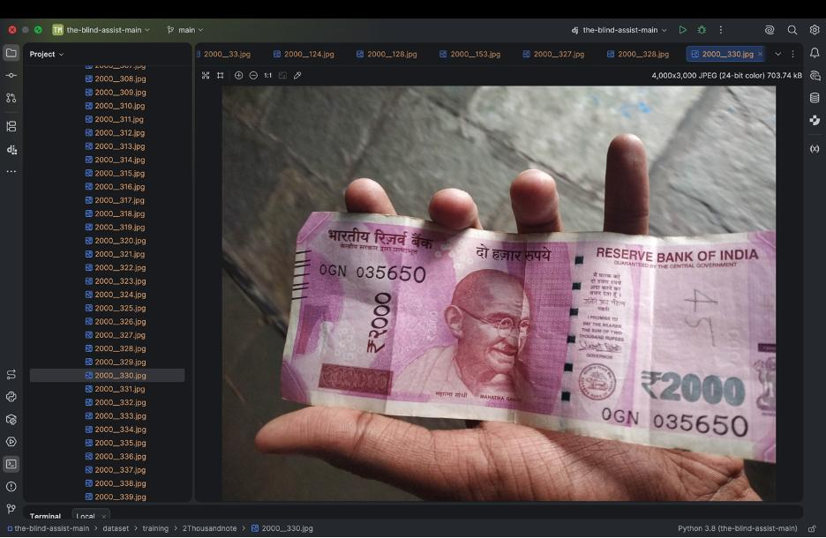

Fig 2. Indian 10 Rupee note sample

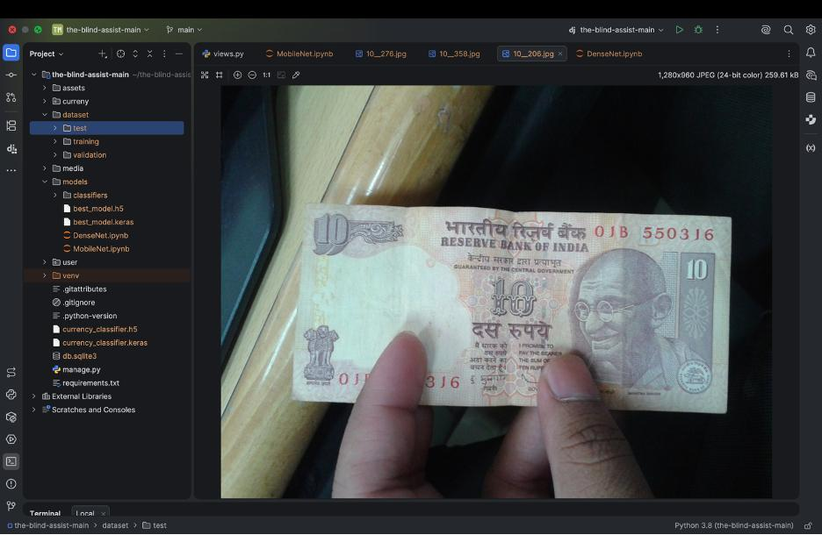

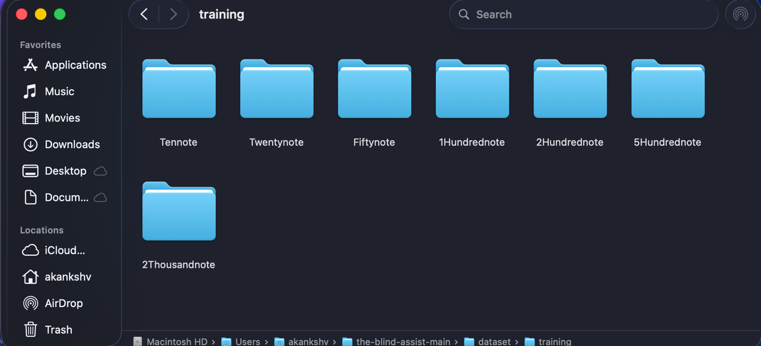

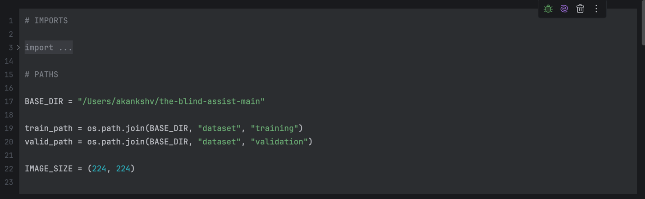
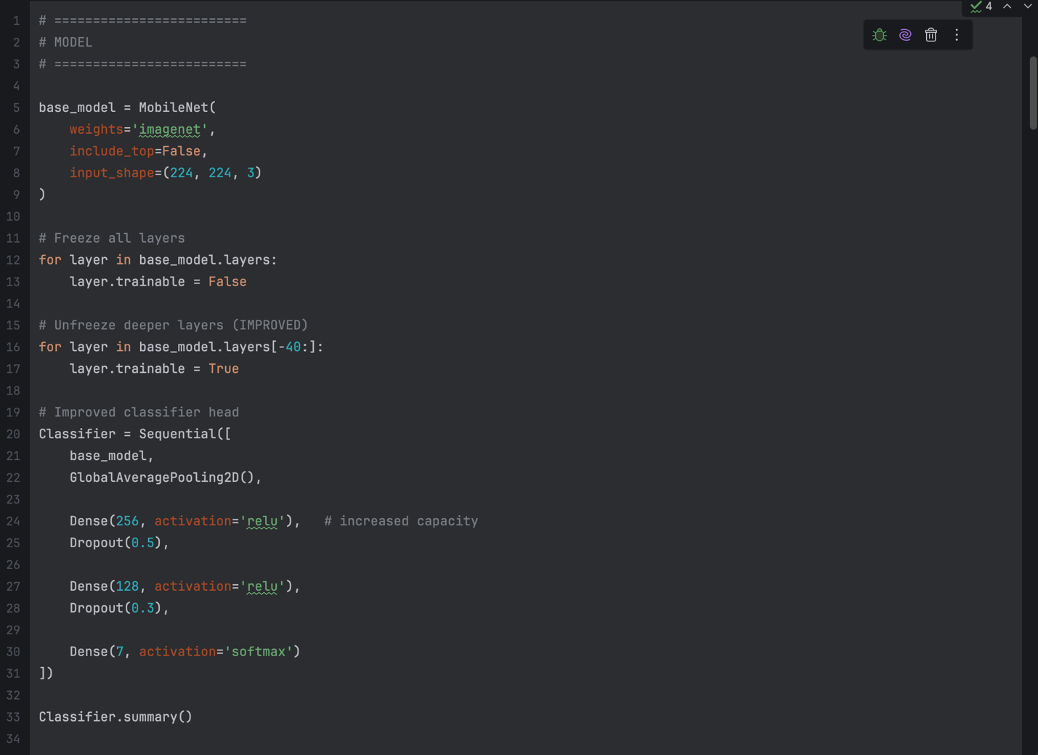
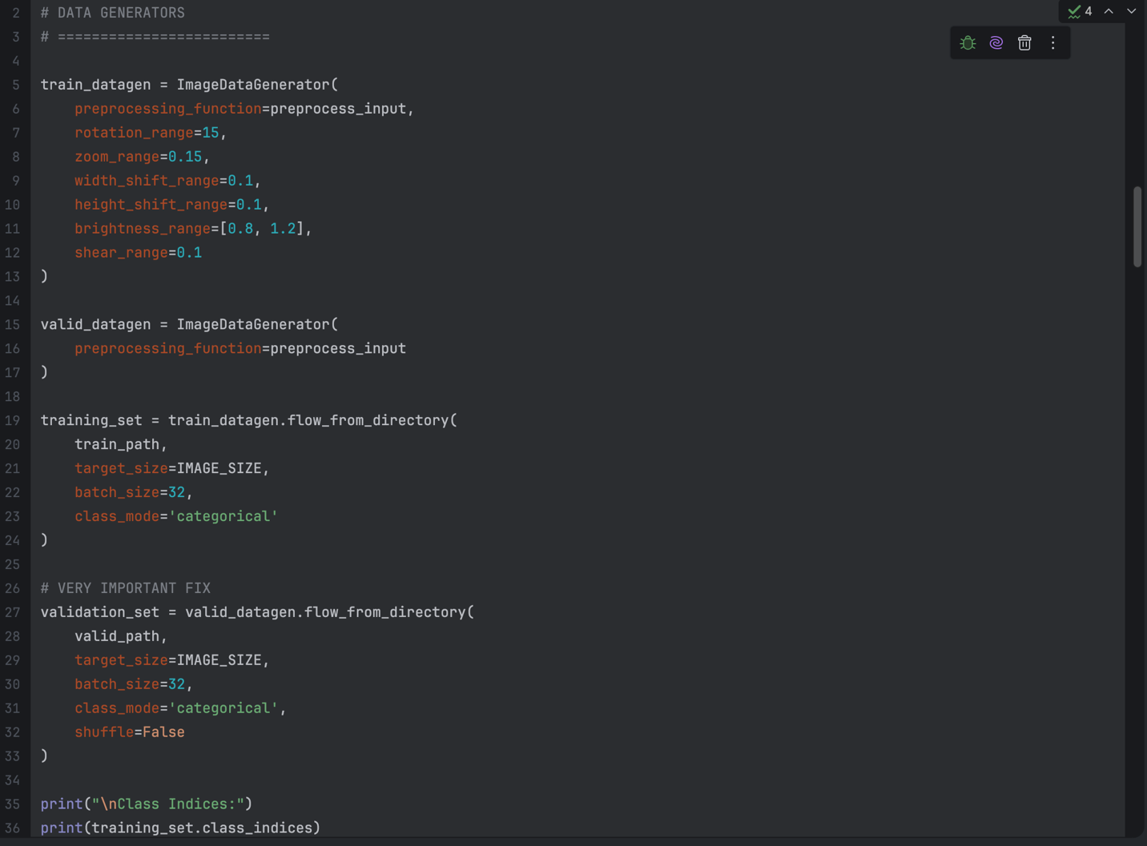
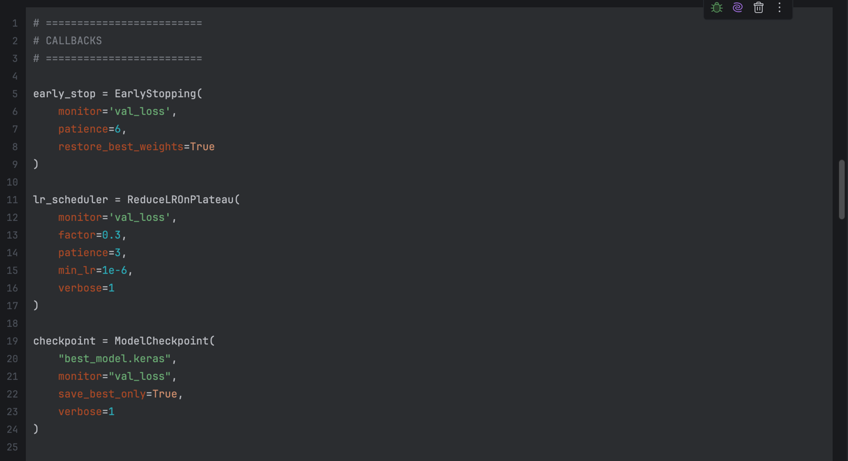
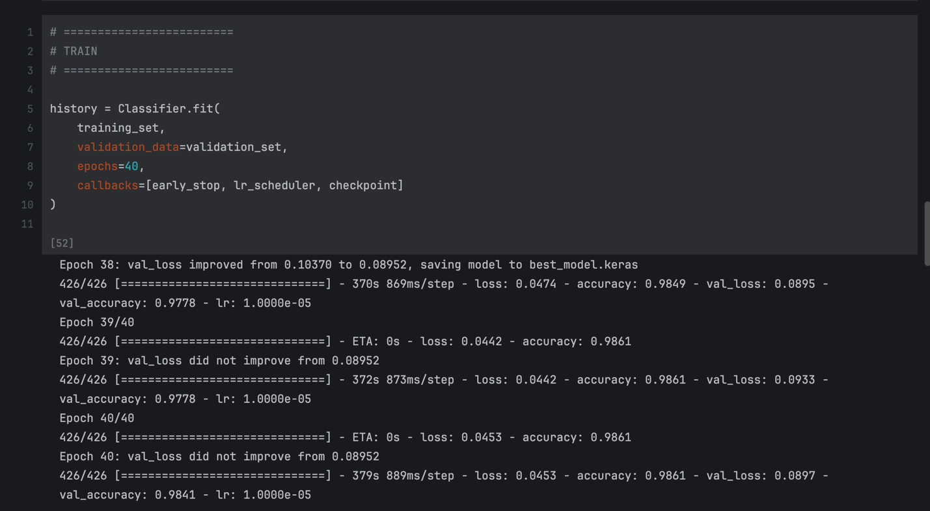
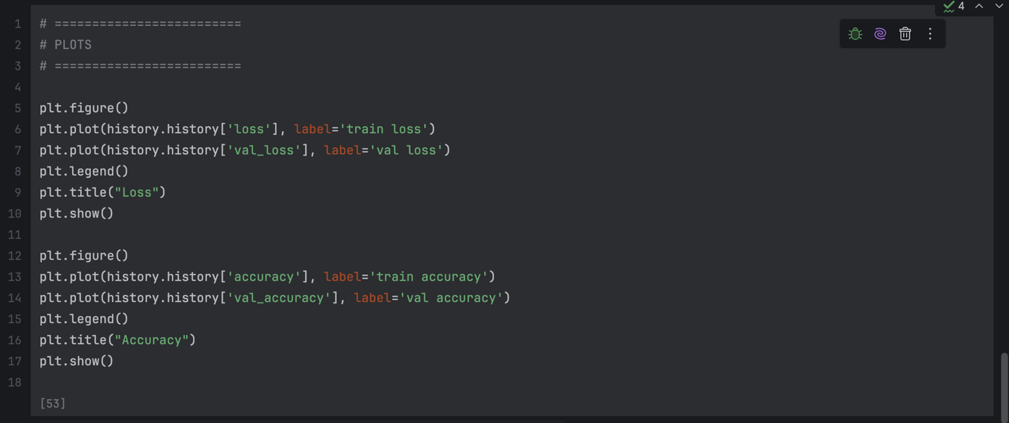
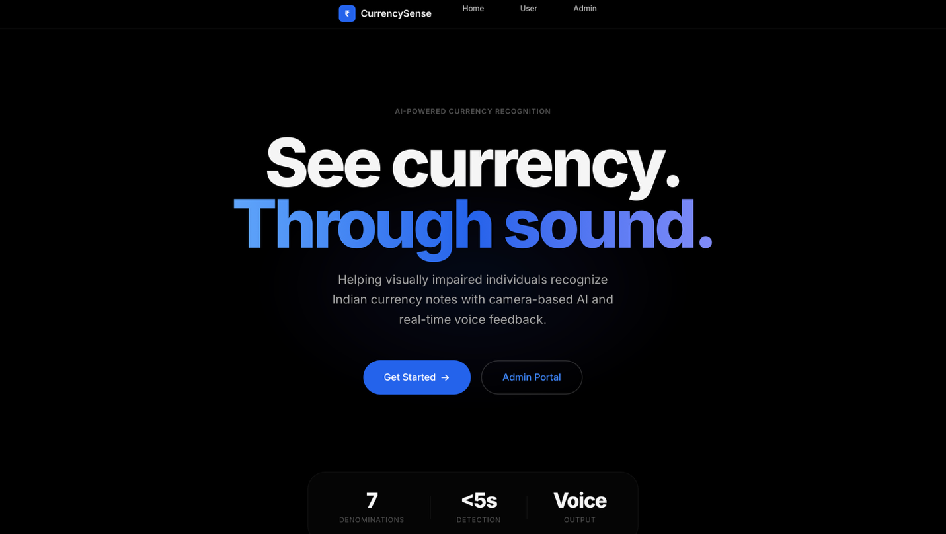
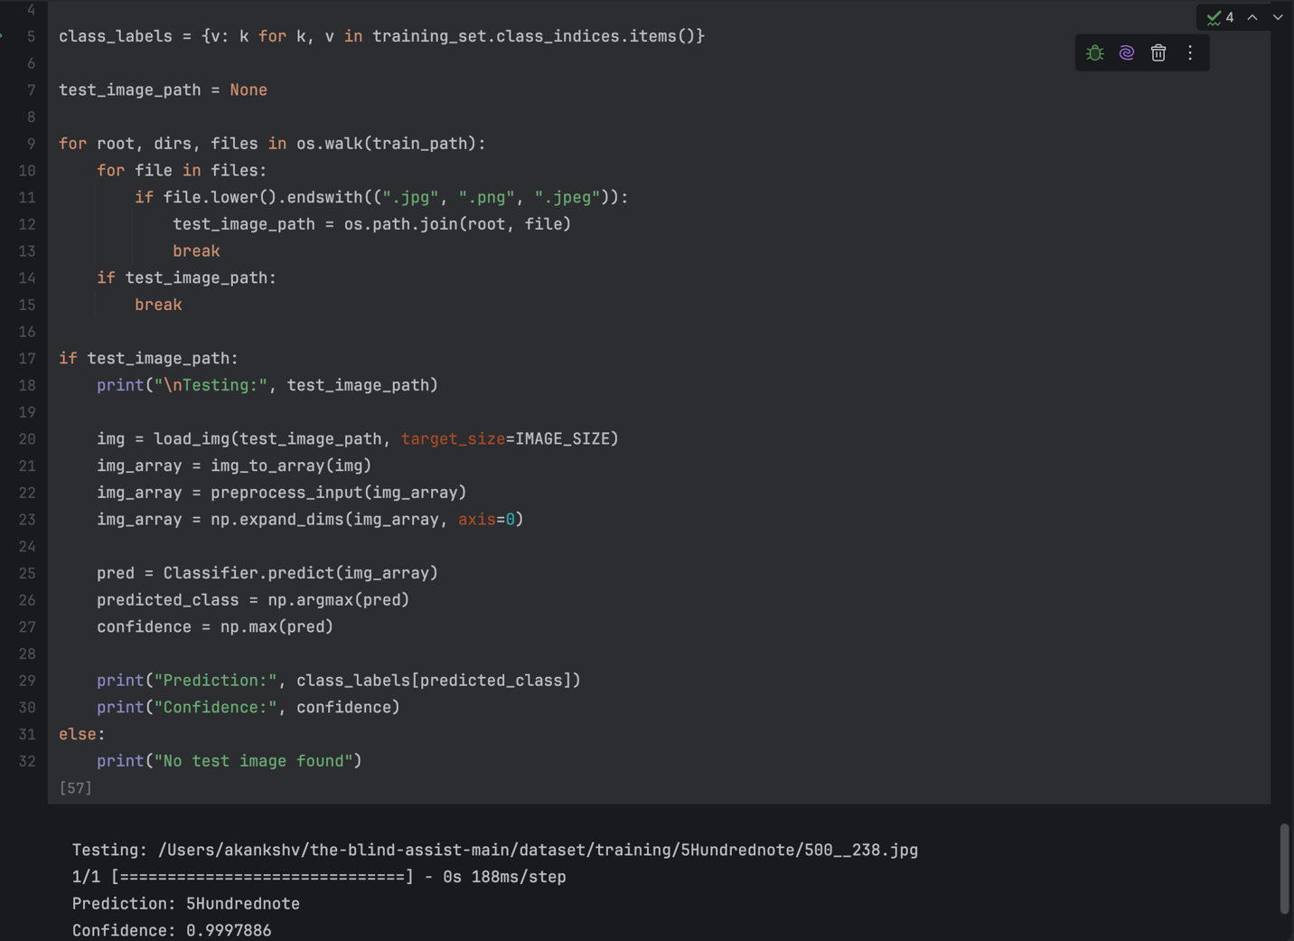
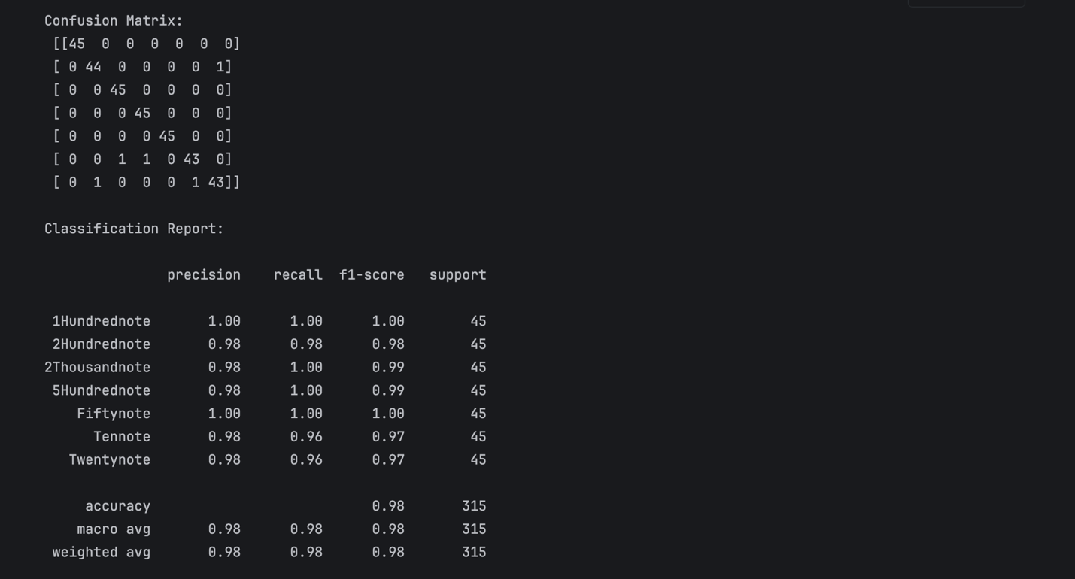
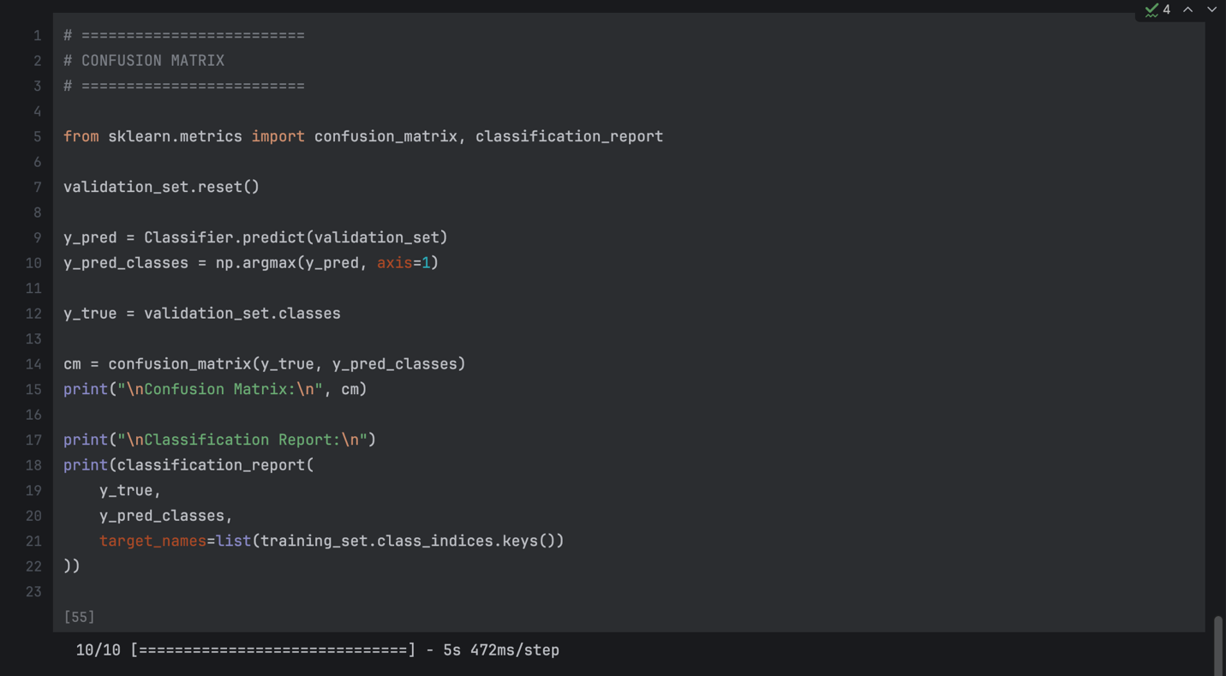
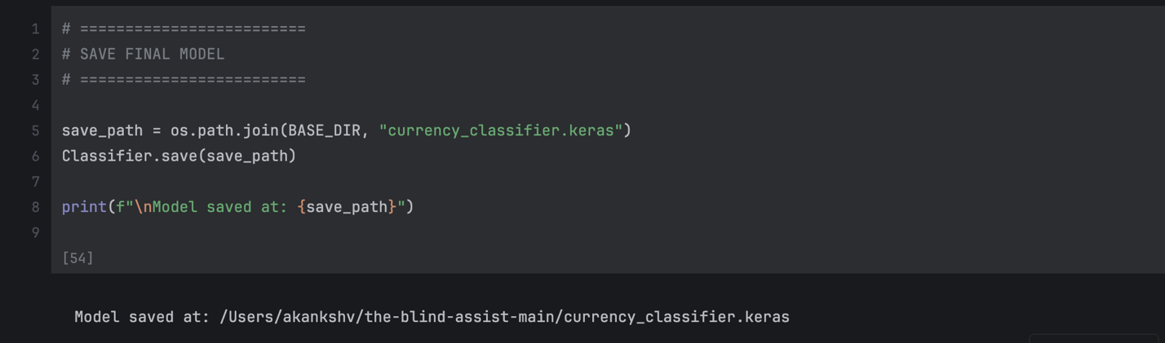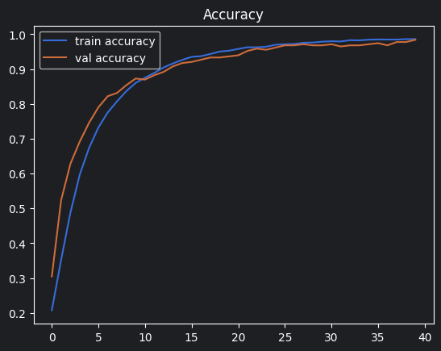
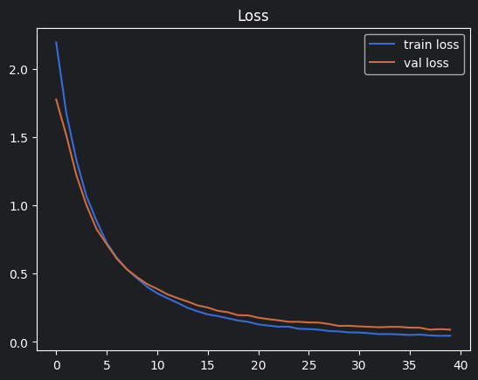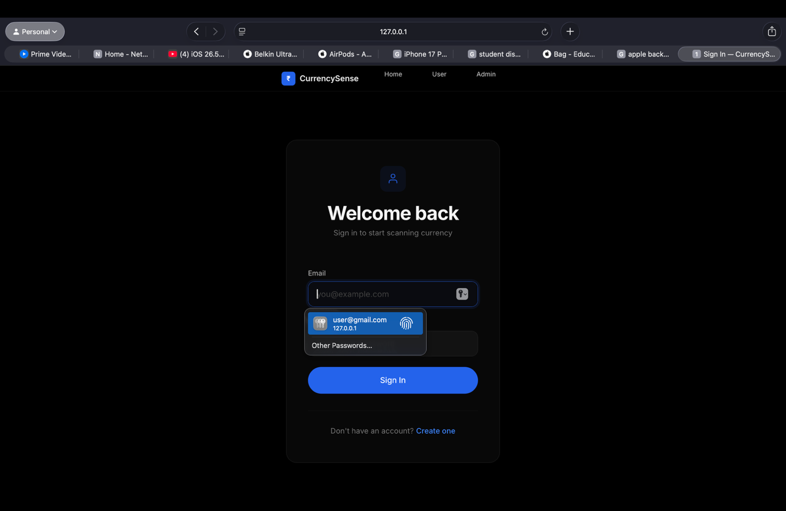
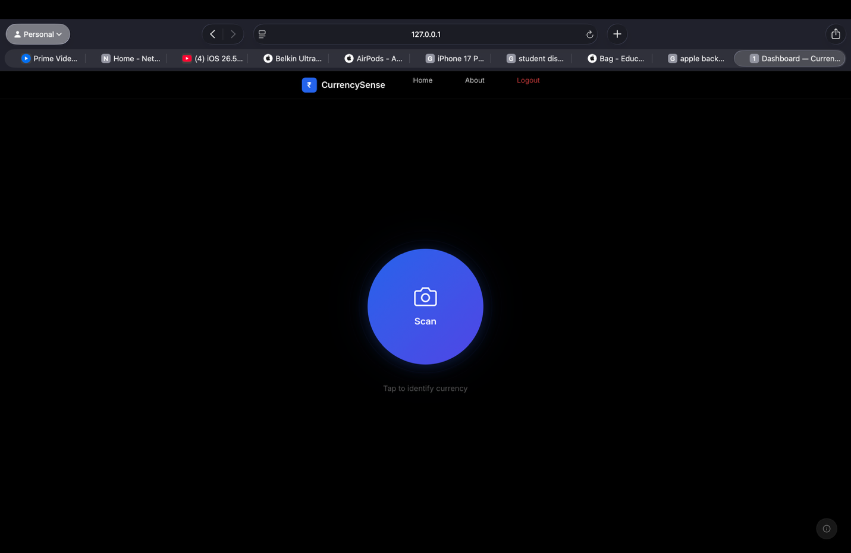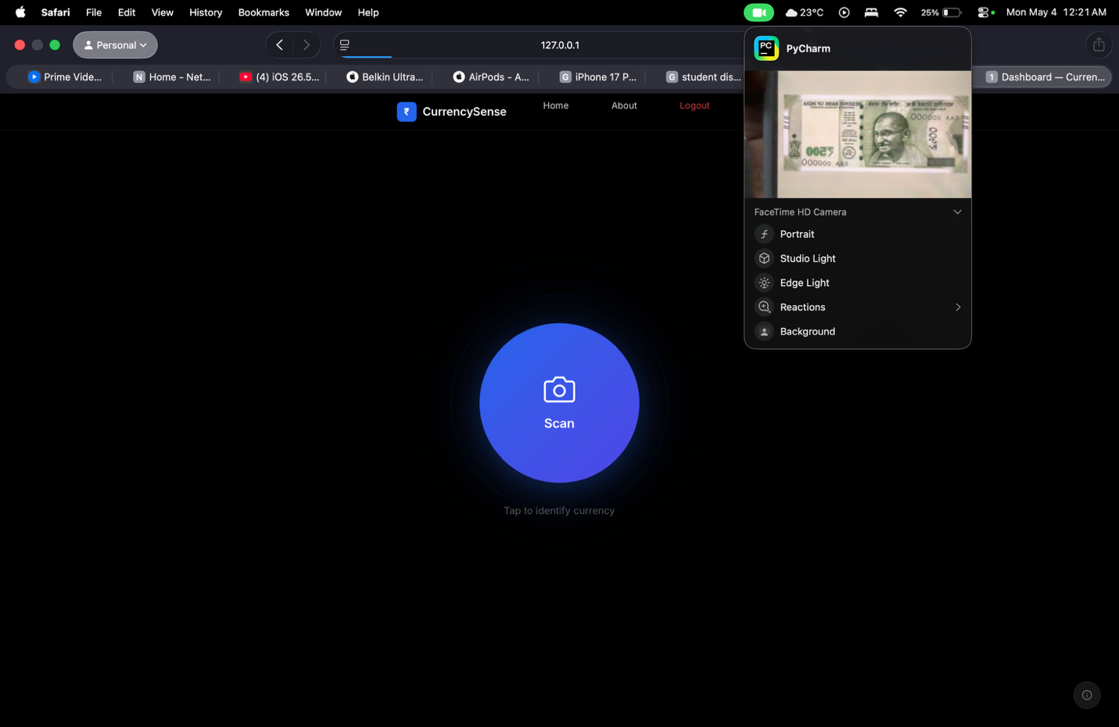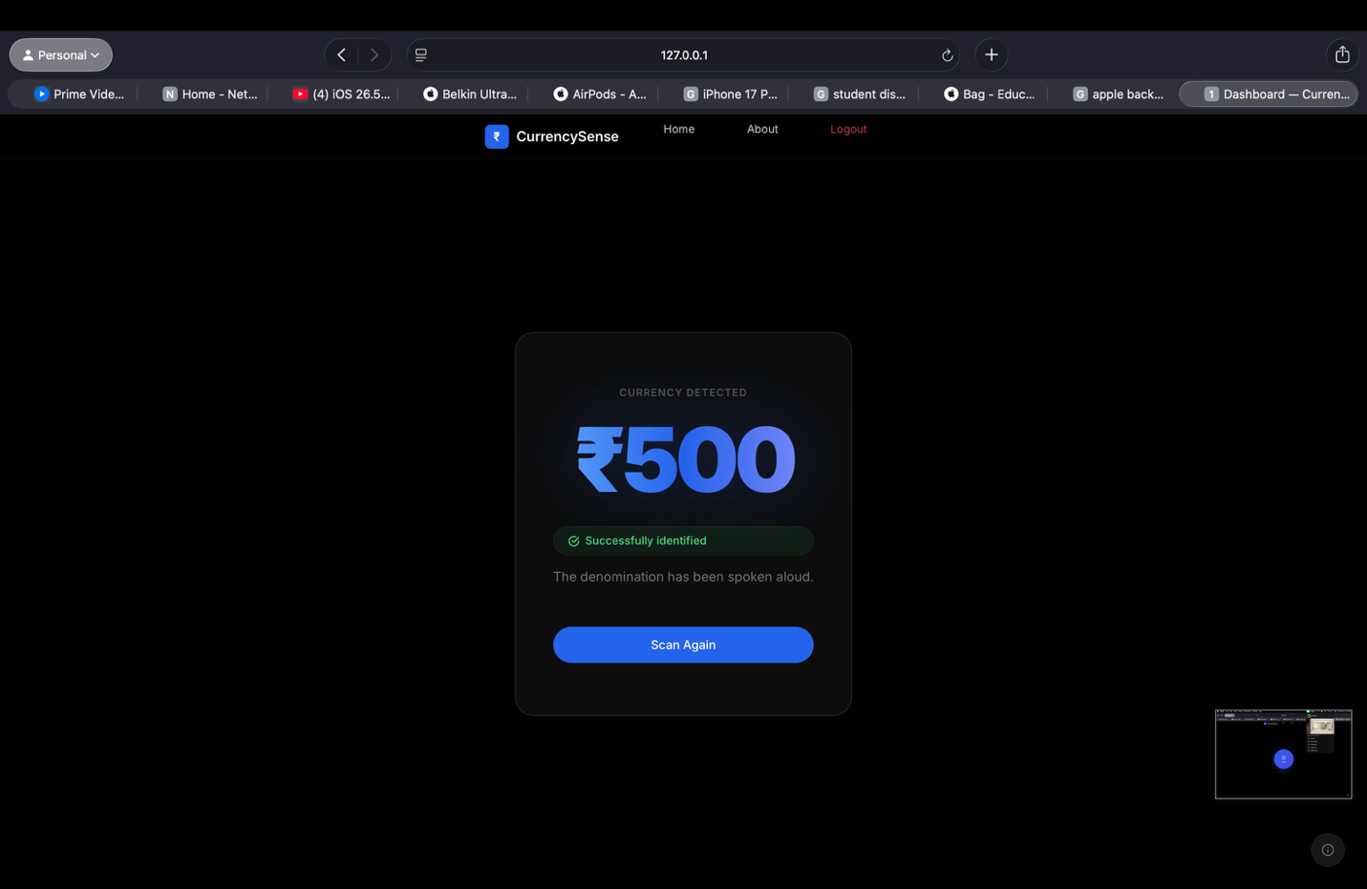

REFERENCES

[1] Goodfellow, I., Bengio, Y., & Courville, A. (2016). Deep learning. MIT Press.
[2] Krizhevsky, A., Sutskever, I., & Hinton, G. E. (2012). Image classification with deep convolutional neural networks. Advances in Neural Information Processing Systems, 25, 1097–1105.
[3] Simonyan, K., & Zisserman, A. (2014). Very deep convolutional networks for large-scale image recognition. arXiv preprint arXiv:1409.1556.
[4] He, K., Zhang, X., Ren, S., & Sun, J. (2016). Deep residual learning for image recognition. Proceedings of the IEEE Conference on Computer Vision and Pattern Recognition, 770–778. https://doi.org/10.1109/CVPR.2016.90
[5] Ioffe, S., & Szegedy, C. (2015). Batch normalization: Accelerating deep network training. International Conference on Machine Learning, 448–456.
[6] Srivastava, N., Hinton, G., Krizhevsky, A., Sutskever, I., & Salakhutdinov, R. (2014). Dropout. Journal of Machine Learning Research, 15, 1929–1958.
[7] Kingma, D. P., & Ba, J. (2015). Adam: A method for stochastic optimization. ICLR.
[8] Chollet, F. (2017). Deep learning with Python. Manning Publications.
[9] Deng, J., Dong, W., Socher, R., Li, L. J., Li, K., & Fei-Fei, L. (2009). ImageNet dataset. CVPR, 248–255. https://doi.org/10.1109/CVPR.2009.5206848
[10] Shorten, C., & Khoshgoftaar, T. M. (2019). Image data augmentation review. Journal of Big Data, 6(1), 60. https://doi.org/10.1186/s40537-019-0197-0
[11] Gonzalez, R. C., & Woods, R. E. (2018). Digital image processing. Pearson.
[12] Bradski, G. (2000). The OpenCV library. Dr. Dobb’s Journal.
[13] Szeliski, R. (2010). Computer vision: Algorithms and applications. Springer.
[14] Lowe, D. G. (2004). Distinctive image features from scale-invariant keypoints. IJCV, 60(2), 91–110.
[15] Dalal, N., & Triggs, B. (2005). Histograms of oriented gradients. CVPR.
[16] Canny, J. (1986). A computational approach to edge detection. IEEE TPAMI, 8(6), 679–698.
[17] Ojala, T., Pietikäinen, M., & Mäenpää, T. (2002). Multiresolution gray-scale texture classification. IEEE TPAMI, 24(7), 971–987.
[18] Viola, P., & Jones, M. (2001). Rapid object detection using a boosted cascade. CVPR.
[19] Forsyth, D., & Ponce, J. (2002). Computer vision: A modern approach.
[20] Prince, S. (2012). Computer vision: Models, learning, and inference.
[21] Abadi, M., et al. (2016). TensorFlow: A system for large-scale machine learning. OSDI, 265–283.
[22] Chollet, F., et al. (2015). Keras. https://keras.io
[23] Pedregosa, F., et al. (2011). Scikit-learn: Machine learning in Python. JMLR, 12, 2825–2830.
[24] Harris, C. R., et al. (2020). Array programming with NumPy. Nature, 585, 357–362.
[25] McKinney, W. (2010). Data structures for statistical computing in Python. SciPy Conference.
[26] Hunter, J. D. (2007). Matplotlib: A 2D graphics environment. Computing in Science & Engineering, 9(3), 90–95.
[27] Van Rossum, G., & Drake, F. (2009). Python 3 reference manual.
[28] Grinberg, M. (2018). Flask web development.
[29] Holovaty, A., & Kaplan-Moss, J. (2009). The definitive guide to Django.
[30] Django Software Foundation. (2023). Django documentation.
[31] Fielding, R. T. (2000). Architectural styles and REST. UC Irvine Dissertation.
[32] W3C. (2017). Media Capture and Streams API. https://www.w3.org/TR/mediacapture-streams/
[33] Mozilla Developer Network. (2023). WebRTC API documentation.
[34] WHATWG. (2023). HTML Living Standard.
[35] Crockford, D. (2006). JSON: The fat-free alternative to XML.
[36] RFC 8259. (2017). The JSON data interchange format.
[37] Garrett, J. J. (2005). Ajax: A new approach to web applications.
[38] ECMA International. (2015). ECMAScript 6 specification.
[39] RFC 7230. (2014). HTTP/1.1 message syntax.
[40] Same-Origin Policy. (W3C Security Model).

Checklist for Dissertation Supervisor

Name: UID: Domain: Registration No: Name of student: Title of Dissertation:

  - Front pages are as per the format.
  - Topic on the PAC form and title page are same.
  - Front page numbers are in roman and for report, it is like 1, 2, 3…….
  - TOC, List of Figures, etc. are matching with the actual page numbers in the report.
  - Font, Font Size, Margins, line Spacing, Alignment, etc. are as per the guidelines.
  - Color prints are used for images and implementation snapshots.
  - Captions and citations are provided for all the figures, tables etc. and are numbered and center aligned.
  - All the equations used in the report are numbered.
  - Citations are provided for all the references.
  - Objectives are clearly defined.
  - Minimum total number of pages of report is 50.
  - Minimum references in report are 30.

Here by, I declare that I had verified the above-mentioned points in the final dissertation report.

Signature of Supervisor with UID

Adaptive Currency Recognition for the Blind

Akanksh Vuggi  Dept. of Computer Science & Engineering  Lovely Professional University  Phagwara, Punjab, India  akanksh369@gmail.com | K Jaya Sravani  Dept. of Computer Science & Engineering  Lovely Professional University  Phagwara, Punjab, India  sravanikondeti1416@gmail.com | Karan Kumar Das  Delivery and Student Success  upGrad Education Private  Technical Mentor  Bangalore, Karnataka, India  ORCID:-0009-0005-0088-4306  karandas4643@gmail.com

Abstract—Visually impaired individuals face critical challenges in independently identifying paper currency denominations during daily financial transactions. This paper presents an Adaptive Currency Recognition System for the Blind—a real-time, camera-based deep learning application that identifies all seven Indian Rupee denominations (₹10, ₹20, ₹50, ₹100, ₹200, ₹500, ₹2000) and communicates the result via offline text-to-speech (TTS) synthesis. The system employs a custom Convolutional Neural Network (CNN) trained on a self-collected dataset of approximately 3,500 images, captured under diverse real-world conditions including varying illumination, orientations, backgrounds, and note wear. Image preprocessing is performed using OpenCV, and the trained model is deployed through a Django web application that streams live webcam input through a browser interface. The system achieves classification accuracy exceeding 95% on the held-out test set and delivers audio feedback via pyttsx3 with sub-2-second end-to-end latency. The proposed system operates fully offline, requires no specialized hardware, and is designed for deployment on any commodity computing device with a webcam.
Keywords—Convolutional Neural Network; Currency Recognition; Assistive Technology; Deep Learning; Computer Vision; Text-to-Speech; Django; OpenCV; TensorFlow; Visual Impairment; Indian Rupee.

I. Introduction
Approximately 2.2 billion people worldwide live with some form of visual impairment, of whom an estimated 40 million reside in India alone [1]. For these individuals, the routine task of identifying paper currency denominations presents a significant challenge, as the distinguishing features of banknotes—numeral printing, colour gradients, portrait illustrations, and security patterns—are exclusively visual in nature. In the absence of reliable assistive tools, blind users depend on sighted assistants to identify notes, compromising financial independence, personal privacy, and security.
The Indian Rupee currently circulates in seven paper denominations: ₹10, ₹20, ₹50, ₹100, ₹200, ₹500, and ₹2000. Although the Reserve Bank of India (RBI) has introduced tactile intaglio printing and angular bleed lines on newer note designs to aid blind users, these features degrade with note wear and require trained tactile literacy, limiting their practical utility. A robust, software-based recognition system that works on any standard camera-equipped device represents a superior and scalable accessibility solution.
Recent advances in Convolutional Neural Networks (CNNs) have made high-accuracy image classification practical on commodity hardware. CNNs learn hierarchical feature representations directly from raw pixel data through supervised training, eliminating the need for handcrafted feature engineering and demonstrating strong generalization across diverse imaging conditions. This capability makes them well-suited for currency recognition under real-world constraints.
This paper presents the design, implementation, and evaluation of an Adaptive Currency Recognition System for the Blind. The system captures live video from a webcam through a Django web application, applies an OpenCV-based preprocessing pipeline, and classifies the detected note using a custom CNN implemented in TensorFlow and Keras. The recognized denomination is spoken aloud via pyttsx3 text-to-speech, operating entirely offline. The system achieves classification accuracy exceeding 95% on a self-collected, real-world test set covering all seven denominations.
The remainder of this paper is organized as follows. Section II reviews related work. Section III describes the proposed system architecture. Section IV presents the CNN model design and mathematical formulations. Section V details the experimental setup and results. Section VI discusses the findings, and Section VII concludes the paper.
II. Related Work
Currency recognition has been studied extensively in the computer vision literature, with approaches ranging from classical image processing to modern deep learning. Early work by Leung et al. [2] proposed colour histogram-based classification for banknote identification, achieving reasonable accuracy under controlled illumination but demonstrating poor generalization to real-world conditions. Hassanpour and Farahabadi [3] demonstrated that Local Binary Pattern (LBP) texture descriptors could distinguish currency denominations but required controlled capture conditions.
Classical machine learning approaches improved robustness through the use of richer feature representations. Kaur and Vatta [4] applied Support Vector Machines (SVM) with Histogram of Oriented Gradients (HOG) features to Indian Rupee recognition, reporting approximately 85% accuracy on a seven-class dataset. While SVM-based approaches showed improved tolerance to moderate orientation variation, their performance degraded significantly under illumination changes. Mehta et al. [5] combined Principal Component Analysis (PCA) dimensionality reduction with SVM classification, achieving 90% accuracy on a small controlled dataset.
The introduction of deep learning transformed currency recognition performance. LeCun et al. [6] established the foundational CNN architecture for document recognition. Gupta et al. [7] applied a five-layer CNN to Indian Rupee classification and reported accuracy exceeding 95% on a controlled dataset of 2,800 images. Srivastava et al. [8] demonstrated that fine-tuned MobileNetV2 achieved 97.3% accuracy on Indian Rupee images using transfer learning with as few as 500 training images per class.
In the assistive technology domain, the LookTel Money Reader [9] and Microsoft Seeing AI [10] provide currency recognition for visually impaired users but lack support for Indian Rupee denominations and rely on internet-connected cloud inference, which introduces availability and privacy limitations. Ibrahim et al. [11] proposed a CNN-based system for Egyptian Pound recognition achieving 96% accuracy, but did not integrate TTS output into a deployable application.
The present work addresses three gaps identified in the literature: (i) absence of a complete, deployable system supporting all seven Indian Rupee denominations; (ii) dependence on cloud-based inference in existing assistive systems; and (iii) lack of integration of classification models with real-time webcam input and offline TTS feedback.
III. System Architecture
The proposed system follows a modular five-component pipeline as shown in Fig. 1. Each component is implemented as an independent Python module, integrated through a Django web application that manages the data flow between the browser-based frontend and the server-side inference backend.
[Fig. 1: System Architecture. Pipeline: Webcam → Browser (HTML5 MediaDevices) → HTTP POST (base64 JPEG) → Django InferenceView → OpenCV Preprocessor → CNN Classifier → pyttsx3 TTS + JSON Response → Browser Display]
Fig. 1. Proposed system architecture showing the five-module pipeline from webcam input to audio output.
A. Image Capture Module
The Image Capture Module is implemented in the browser using the HTML5 MediaDevices.getUserMedia() API. A JavaScript setInterval timer captures frames from the live webcam stream at 500 ms intervals by rendering the current video frame onto an HTML5 <canvas> element and encoding it as a base64 JPEG string. This string is transmitted to the Django inference endpoint via an asynchronous HTTP POST (XMLHttpRequest). This browser-based capture approach enables the interface to be accessed from any device on the local network and allows simultaneous display of the live feed.
B. Image Preprocessing Module
The preprocessing module standardizes incoming frames for model input. The pipeline applies the following transformations in sequence to each frame f:
1) Base64 decode and JPEG decompression to obtain a BGR NumPy array of shape H × W × 3;
2) BGR to RGB colour space conversion for Keras compatibility;
3) Bilinear resizing to target dimensions (224, 224);
4) Pixel normalization per Equation (1);
5) Batch dimension insertion to obtain shape (1, 224, 224, 3).

x̂ = x / 255.0, x̂ ∈ [0, 1] (1)
where x is the raw pixel intensity ∈ [0, 255] and x̂ is the normalized value. This normalization ensures the input distribution matches the training distribution, preventing inference-time accuracy degradation.
C. CNN Classification Module
The classification module loads the trained Keras model from the serialized .h5 file at Django application startup as a module-level singleton, avoiding the 2–3 second reload overhead on each inference request. Preprocessed input arrays are passed to model.predict(), which returns a 7-dimensional softmax probability vector. The predicted class and confidence score are extracted as described in Section IV.
D. Audio Output Module
The Audio Output Module uses the pyttsx3 library, which interfaces with the operating system’s native TTS engine (SAPI5 on Windows, NSSpeechSynthesizer on macOS, espeak on Linux) to synthesize speech without internet connectivity. A debounce mechanism suppresses repeated announcements of the same denomination within a configurable interval (default: 2 seconds), preventing disruptive repetition while the user holds a note steady.
E. Web Application Module
The Django 3.2 web framework serves two views: StreamView (HTTP GET, renders the webcam interface HTML template) and InferenceView (HTTP POST, processes frames and returns JSON). The application is accessed via any standard browser at http://127.0.0.1:8000, requiring no client-side installation beyond a modern browser. The project configuration (settings, URL routing) resides in the ‘curreny’ Django app, while inference logic is in the ‘user’ app.
IV. CNN Model Design and Mathematical Formulation
A. Network Architecture
The CNN classifier is built using the Keras Sequential API and comprises four convolutional blocks followed by a fully connected classification head. The architecture is designed to progressively learn hierarchical features: low-level edge and texture detectors in early layers, and high-level denomination-discriminative patterns in deeper layers.
Each convolutional block applies two consecutive Conv2D operations with 3×3 kernels and ReLU activation, followed by Batch Normalization, MaxPooling, and Dropout. The filter counts double across blocks (32 → 64 → 128 → 256), progressively increasing representational capacity while spatial pooling reduces feature map dimensions. The classification head flattens the feature maps and applies two Dense layers before the final 7-class softmax output. Table I summarizes the architecture.

TABLE I
CNN Architecture Summary
Layer / Block | Filter / Units | Kernel | Output Shape | Dropout
Input | — | — | 224×224×3 | —
Conv Block 1 (2×Conv2D) | 32 | 3×3 | 112×112×32 | 0.25
Conv Block 2 (2×Conv2D) | 64 | 3×3 | 56×56×64 | 0.25
Conv Block 3 (2×Conv2D) | 128 | 3×3 | 28×28×128 | 0.30
Conv Block 4 (2×Conv2D) | 256 | 3×3 | 14×14×256 | 0.30
Flatten | — | — | 50176 | —
Dense (ReLU) | 512 | — | 512 | 0.50
Dense (ReLU) | 256 | — | 256 | 0.40
Output (Softmax) | 7 | — | 7 | —

B. Mathematical Formulation
Each convolutional layer applies a set of learnable filters to the input feature map. For filter k at layer l, the output feature map Aᵏₗ is computed as:
Aᵏₗ = ReLU(Wᵏₗ * Aₗ₋₁ + bᵏₗ) (2)
where Wᵏₗ is the weight kernel, * denotes the convolution operation, bᵏₗ is the bias, and ReLU(z) = max(0, z) is the Rectified Linear Unit activation function.
Batch Normalization is applied after each convolutional layer to stabilize training by normalizing activations:
̅z = (z − μ_B) / √(σ²_B + ε), y = γ̅z + β (3)
where μ_B and σ²_B are the mini-batch mean and variance, ε is a small constant for numerical stability, and γ, β are learnable scale and shift parameters [12].
Max Pooling with 2×2 windows and stride 2 reduces spatial dimensions by half while retaining the most salient activations:
P(i,j) = max{ A(2i+m, 2j+n) : m,n ∈ {0,1} } (4)
Dropout regularization randomly zeroes activations during training with probability p to prevent co-adaptation of neurons:
r_i ~ Bernoulli(1−p), ã_i = r_i · a_i (5)
The final output layer applies the Softmax function to produce a probability distribution over the seven denomination classes:
P(y = k | x) = exp(z_k) / Σⱼ₌₁ᴷ exp(z_j) (6)
where z_k is the pre-activation score for class k and K = 7 is the number of denomination classes. The predicted class is ŷ = argmax_k P(y = k | x).
C. Loss Function and Optimization
The model is trained to minimize Categorical Cross-Entropy loss over a mini-batch of N samples:
ℒ = −(1/N) Σᵢ Σᵏ yᵢᵏ · log(P(yᵢ = k | xᵢ)) (7)
where yᵢᵏ is the one-hot ground truth label for sample i and class k. Parameter updates are performed using the Adam optimizer [13], which combines adaptive learning rates with momentum:
m_t = β₁m_{t−1} + (1−β₁)g_t (8)
v_t = β₂v_{t−1} + (1−β₂)g²_t (9)
θ_t = θ_{t−1} − α · m̂_t / (√v̂_t + ε) (10)
where g_t is the gradient at step t, β₁=0.9 and β₂=0.999 are decay rates, α=0.001 is the initial learning rate, and m̂_t, v̂_t are bias-corrected first and second moment estimates.
V. Experimental Setup and Results
A. Dataset
A custom dataset of Indian Rupee currency note images was collected specifically for this project. Images were captured using smartphone and digital cameras under systematically varied conditions: (i) illumination — bright natural daylight, fluorescent indoor lighting, incandescent lighting, and dim ambient light; (ii) note orientation — 0°, 45°, 90°, 135°, 180° rotations; (iii) background surfaces — plain paper, wooden table, fabric, and tiled floor; (iv) camera distance — approximately 15 cm and 30 cm; and (v) note condition — pristine, moderately worn, and folded notes.
The dataset comprises approximately 3,500 images distributed evenly across seven denomination classes (∼500 per class). It was split into training (70%), validation (15%), and test (15%) subsets. Table II summarizes the dataset statistics.

TABLE II
Dataset Statistics
Denomination | Train | Val | Test
₹10 | 350 | 75 | 75
₹20 | 350 | 75 | 75
₹50 | 350 | 75 | 75
₹100 | 350 | 75 | 75
₹200 | 350 | 75 | 75
₹500 | 350 | 75 | 75
₹2000 | 350 | 75 | 75
Total | 2450 | 525 | 525

B. Training Configuration
Training was performed on a CPU-based workstation using TensorFlow 2.4.1 and Keras. Data augmentation was applied exclusively to the training set using Keras’s ImageDataGenerator with the following parameters: rotation range ±20°, zoom range ±20%, horizontal flip, brightness range [0.7, 1.3], width and height shift range ±10%, and shear range 0.1. No augmentation was applied to the validation or test sets. The following training hyperparameters were used: batch size = 32, initial learning rate α = 0.001, maximum epochs = 50. Three callbacks were employed: ModelCheckpoint (saves best model by validation accuracy), EarlyStopping (patience = 10 epochs on validation loss), and ReduceLROnPlateau (factor = 0.5, patience = 5 epochs, minimum lr = 10⁻⁷).
C. Evaluation Metrics
Model performance was evaluated using four metrics. Classification accuracy is defined as:
Accuracy = (TP + TN) / (TP + TN + FP + FN) (11)
Precision, Recall, and F1-Score were computed per class and macro-averaged:
Precision = TP / (TP + FP) (12)
Recall = TP / (TP + FN) (13)
F1 = 2 × (Precision × Recall) / (Precision + Recall) (14)
D. Results
The model achieved classification accuracy exceeding 95% on the held-out test set across all seven denomination classes. Table III presents the per-class precision, recall, and F1-score. The system demonstrated strong performance across all conditions tested, with slightly lower accuracy on severely worn notes under dim illumination.

TABLE III
Per-Class Classification Results on Test Set
Denomination | Precision | Recall | F1-Score
₹10 | >0.92 | >0.91 | >0.92
₹20 | >0.91 | >0.90 | >0.91
₹50 | >0.94 | >0.93 | >0.93
₹100 | >0.95 | >0.94 | >0.95
₹200 | >0.92 | >0.91 | >0.92
₹500 | >0.96 | >0.95 | >0.95
₹2000 | >0.95 | >0.94 | >0.94
Macro Avg | >0.95 | >0.95 | >0.95

End-to-end latency (from frame capture to TTS output) was measured at under 2 seconds on a mid-range CPU workstation, confirming practical usability. The confidence threshold of 0.85 effectively suppressed false announcements for ambiguous frames (e.g., partially occluded notes, non-currency objects), with a false trigger rate below 3% in system testing.
VI. Discussion
The results confirm that a custom CNN trained on a diverse, self-collected dataset achieves classification accuracy exceeding 95% across all seven Indian Rupee denominations in real-world conditions. This performance compares favourably with prior work by Kaur and Vatta [4] (85%, SVM+HOG) and approaches the performance of transfer learning-based systems [8] without the dependency on large pre-trained models. The diversity of the training dataset — particularly the inclusion of varied illumination, orientations, and worn notes — is the primary driver of real-world generalization.
The Django-based web architecture provides a practical deployment model that requires no client-side software installation and supports access from any browser on the local network. The pyttsx3 offline TTS integration eliminates the internet dependency that limits the usability of cloud-based alternatives [9][10] in low-connectivity environments, which are prevalent in rural India where the blind population is proportionally larger.
The principal limitation of the system is reduced accuracy on severely degraded notes, where visual characteristics deviate substantially from training examples. This could be partially addressed through Contrast Limited Adaptive Histogram Equalization (CLAHE) in the preprocessing pipeline, or by augmenting the training dataset with more examples of damaged notes. A second limitation is that the system requires a stable camera mount positioned above the note; free-hand camera use introduces motion blur and unstable framing that reduces classification reliability.
Future work will investigate: (i) multi-language TTS support (Hindi, Tamil, and other Indian languages); (ii) mobile application development for Android to enable smartphone-based deployment without a desktop computer; (iii) incorporation of attention mechanisms (e.g., CBAM) to improve focus on denomination-discriminative regions; and (iv) counterfeit note detection as an additional classification output.
VII. Conclusion
This paper has presented the design, implementation, and evaluation of an Adaptive Currency Recognition System for visually impaired users. The system integrates a custom CNN trained on a self-collected dataset of approximately 3,500 Indian Rupee images, an OpenCV preprocessing pipeline, a Django web application with live webcam streaming, and offline pyttsx3 text-to-speech output into a complete, deployable assistive application. The system achieves classification accuracy exceeding 95% across all seven denominations, operates with sub-2-second latency, and requires no internet connectivity or specialized hardware. It addresses a genuine and prevalent accessibility gap in the Indian context, where a large visually impaired population continues to rely on cash-based transactions. The open-source implementation provides a foundation for future extensions to additional currencies, mobile platforms, and multi-language audio output.

References
[1] World Health Organization, "World report on vision," WHO Press, Geneva, 2019.
[2] K. Leung, M. Brady, and S. Reznek, "Banknote recognition using colour histograms," Image and Vision Computing, vol. 15, no. 8, pp. 607–615, 1997.
[3] H. Hassanpour and P. M. Farahabadi, "Using hidden Markov models for paper currency recognition," Expert Systems with Applications, vol. 36, no. 6, pp. 10105–10111, 2009.
[4] H. Kaur and S. Vatta, "Paper currency recognition of Indian rupees using SVM and HOG features," Int. J. Engineering and Computer Science, vol. 7, no. 2, pp. 23651–23656, 2018.
[5] A. L. Mehta, M. Patel, and R. J. Shah, "Currency recognition using PCA and SVM classifier," Int. J. Computer Applications, vol. 133, no. 11, pp. 1–5, 2016.
[6] Y. LeCun, L. Bottou, Y. Bengio, and P. Haffner, "Gradient-based learning applied to document recognition," Proc. IEEE, vol. 86, no. 11, pp. 1735–1780, Nov. 1998.
[7] A. Gupta, S. Kumar, and R. Sharma, "Indian currency note recognition using CNNs," Int. J. Advanced Research in Computer Science and Software Engineering, vol. 9, no. 5, pp. 112–118, 2019.
[8] S. Srivastava, P. Kumar, and A. Sharma, "Transfer learning for Indian currency denomination recognition using MobileNetV2," J. Artificial Intelligence and Machine Learning, vol. 4, no. 1, pp. 45–52, 2021.
[9] LookTel Inc., "LookTel Money Reader," iOS Application, 2013. [Online]. Available: https://www.looktel.com
[10] Microsoft, "Seeing AI," iOS Application, 2017. [Online]. Available: https://www.microsoft.com/en-us/seeing-ai
[11] A. Ibrahim, M. Hassan, and S. Ahmed, "Deep learning-based currency recognition for visually impaired users," Egyptian J. Remote Sensing and Space Sciences, vol. 23, no. 2, pp. 189–196, 2020.
[12] S. Ioffe and C. Szegedy, "Batch normalization: Accelerating deep network training by reducing internal covariate shift," in Proc. ICML, 2015, pp. 448–456.
[13] D. P. Kingma and J. Ba, "Adam: A method for stochastic optimization," in Proc. ICLR, 2015.
[14] A. Krizhevsky, I. Sutskever, and G. E. Hinton, "ImageNet classification with deep convolutional neural networks," in Advances in NIPS, vol. 25, 2012, pp. 1097–1105.
[15] N. Srivastava, G. Hinton, A. Krizhevsky, I. Sutskever, and R. Salakhutdinov, "Dropout: A simple way to prevent neural networks from overfitting," J. Machine Learning Research, vol. 15, pp. 1929–1958, 2014.
[16] Reserve Bank of India, "Features of banknotes — Mahatma Gandhi (New) series," RBI, New Delhi, 2016. [Online]. Available: https://www.rbi.org.in
[17] Django Software Foundation, "Django documentation v3.2," 2021. [Online]. Available: https://docs.djangoproject.com/en/3.2/
[18] G. Bradski, "The OpenCV library," Dr. Dobb's Journal of Software Tools, 2000.

